Western Mathematics Exams

Half Yearly Examination

2015
Year 10
Advanced
Mathematics Course

Solutions
Year 10 |  | WME Half Yearly Advanced Maths | Non Calculator
Section 1 Short Answer Section
ANSWERS
No. | WORKING |  | ANSWER
 | 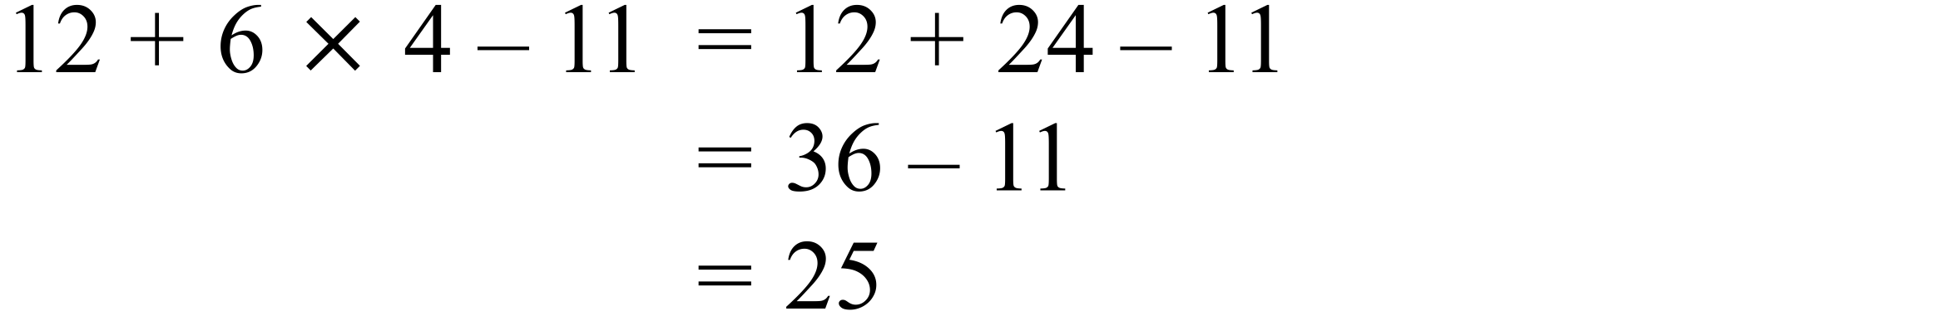 |  | 25
 | 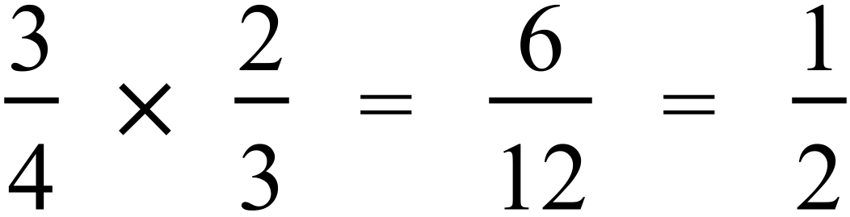 |  | 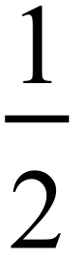
 | 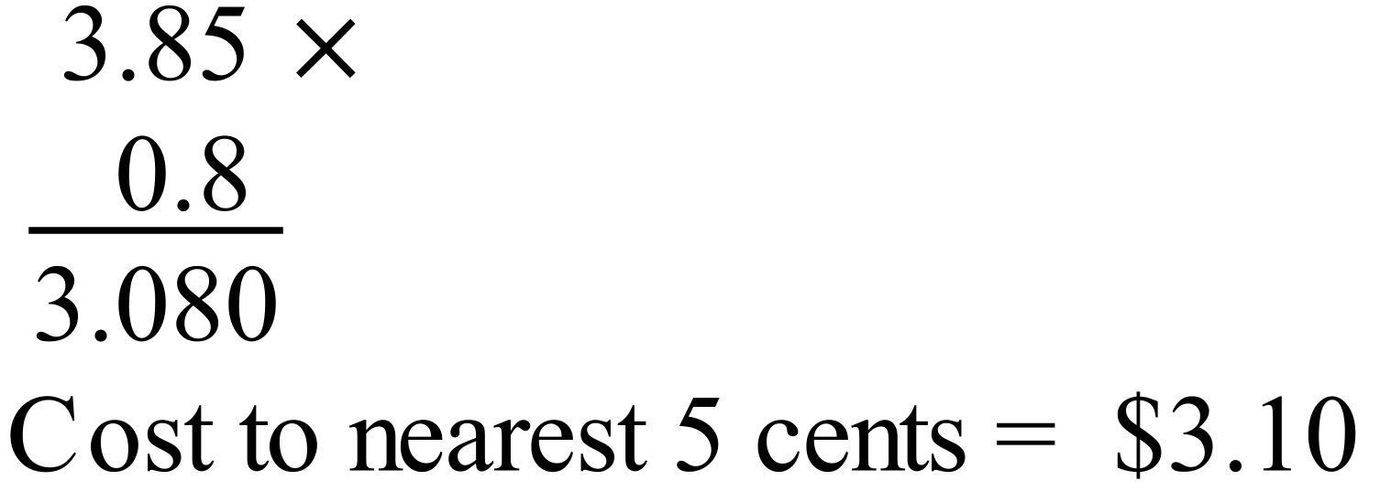 |  | 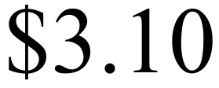
 | 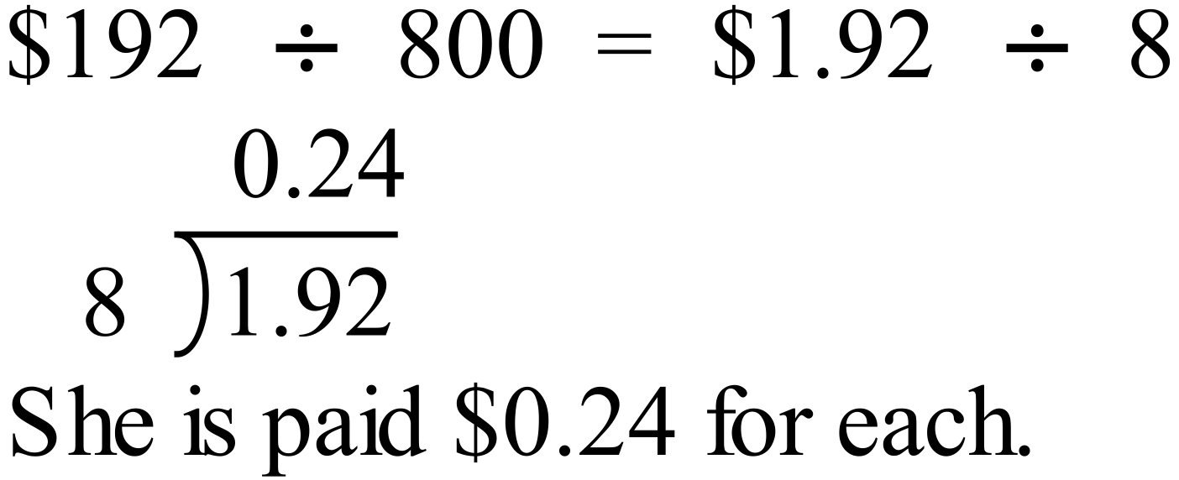 |  | $0.24
 | 30% discount leaves 70% to pay.  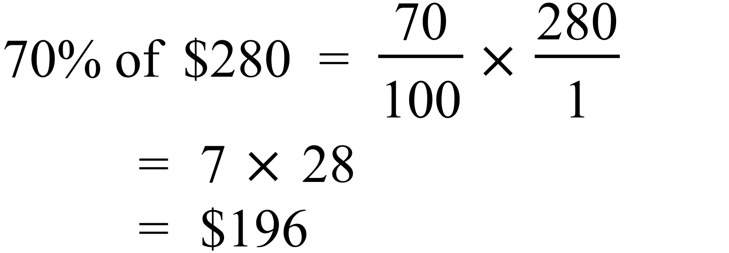 |  | $196
 | 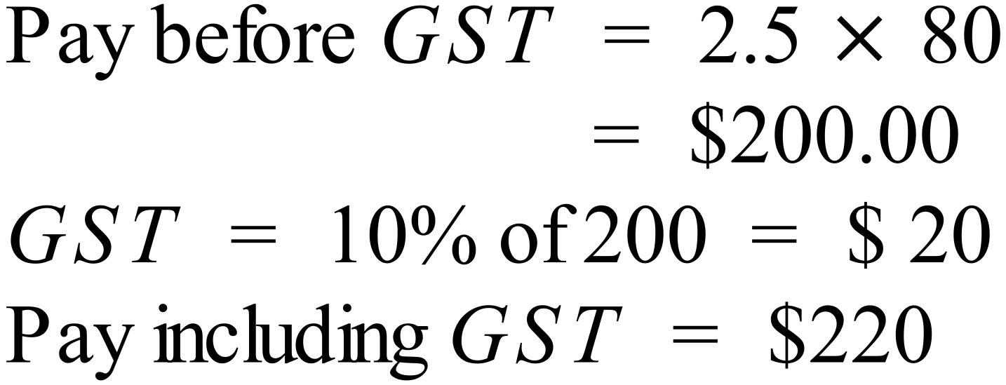 |  | $220
 | 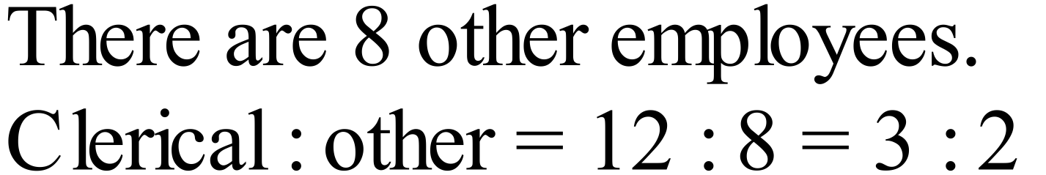 |  | 3 : 2
 | 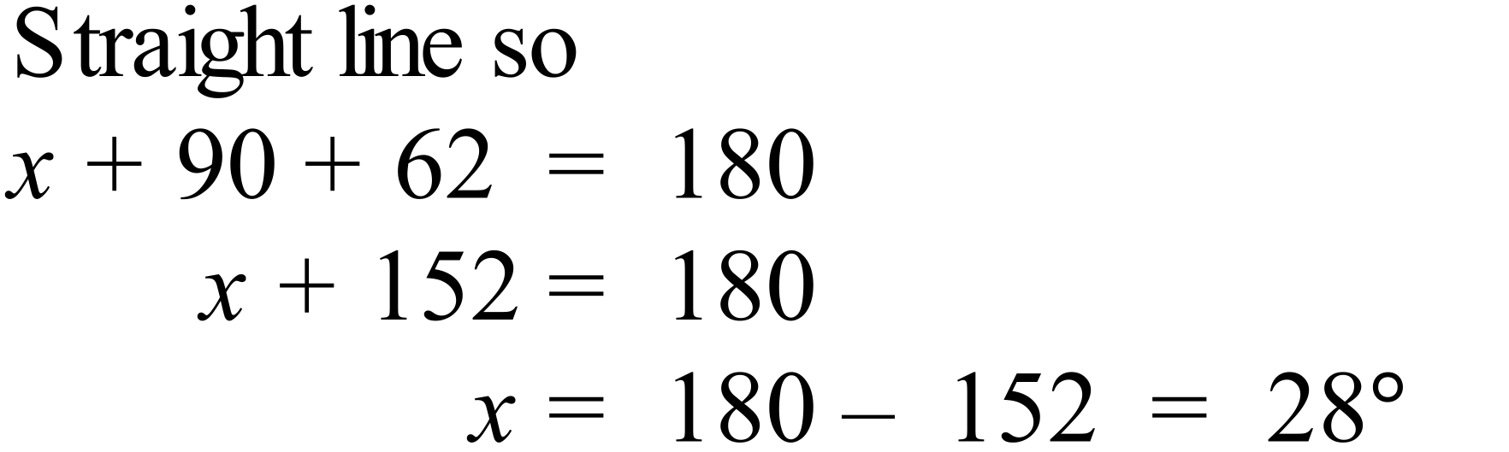 |  | 28º
 | Let third angle = 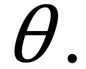  Using angle sum,  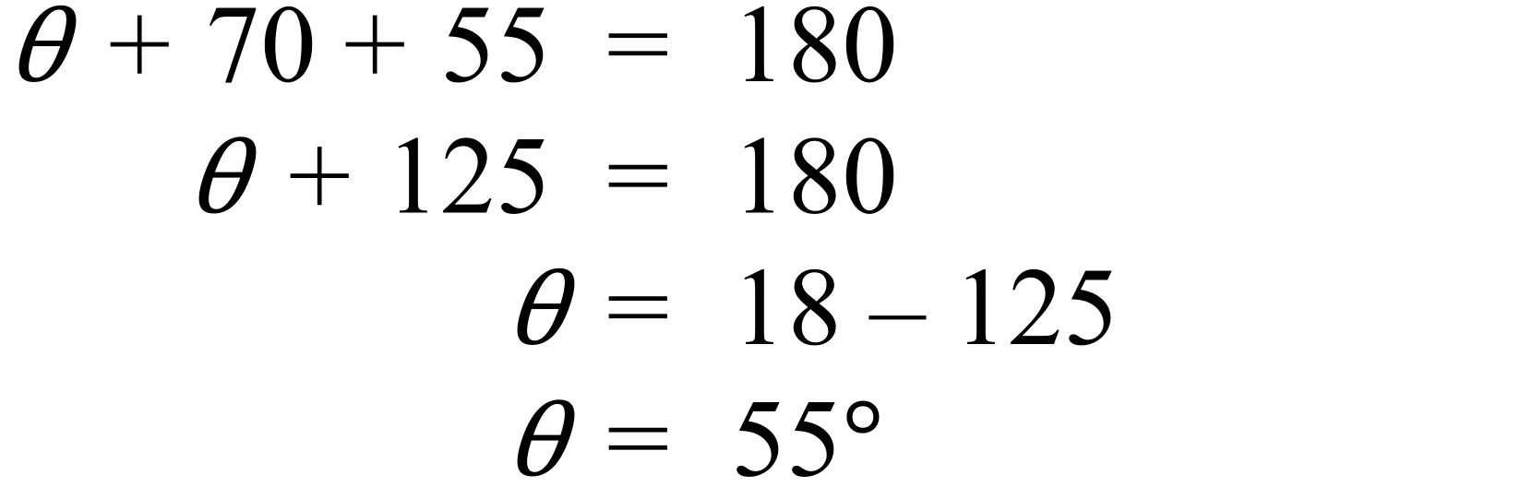  So angles are 55º, 55º and 70º  Triangle is isosceles and acute. |  | isosceles and acute.
 | 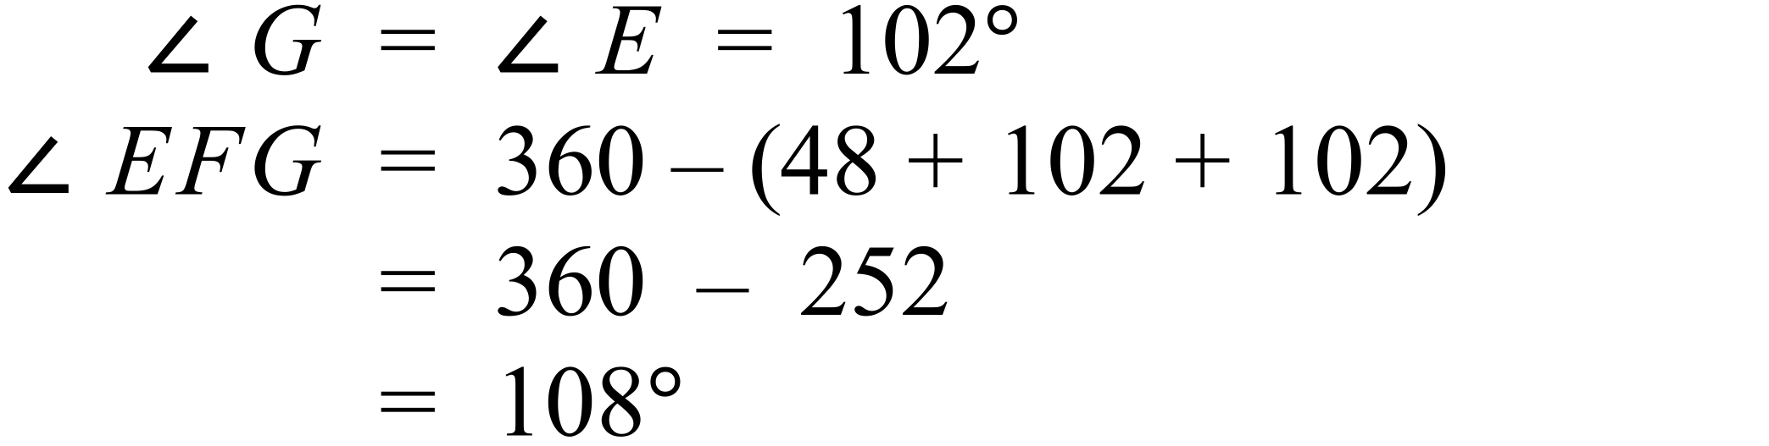 |  | 108º
 | 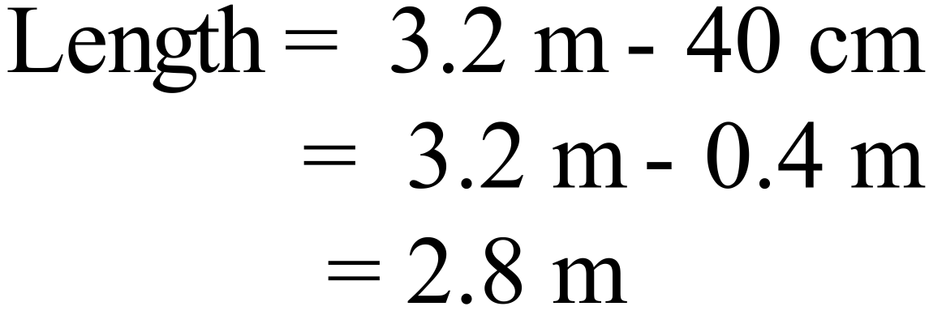 |  | 2.8 m
 | 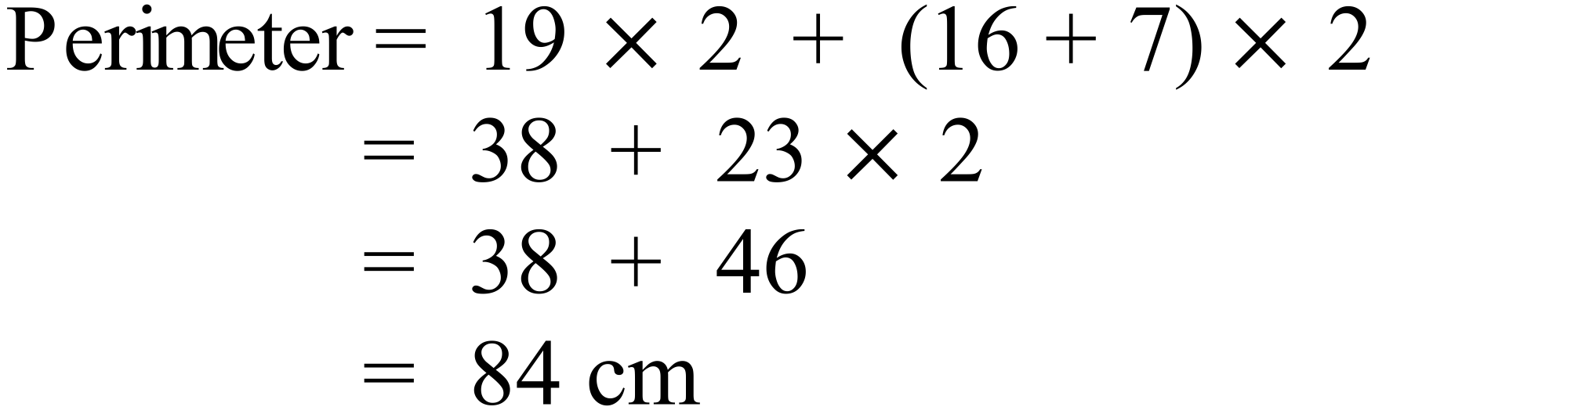 |  | 84 cm
 | The 22 cm base and 60 cm height are perpendicular.  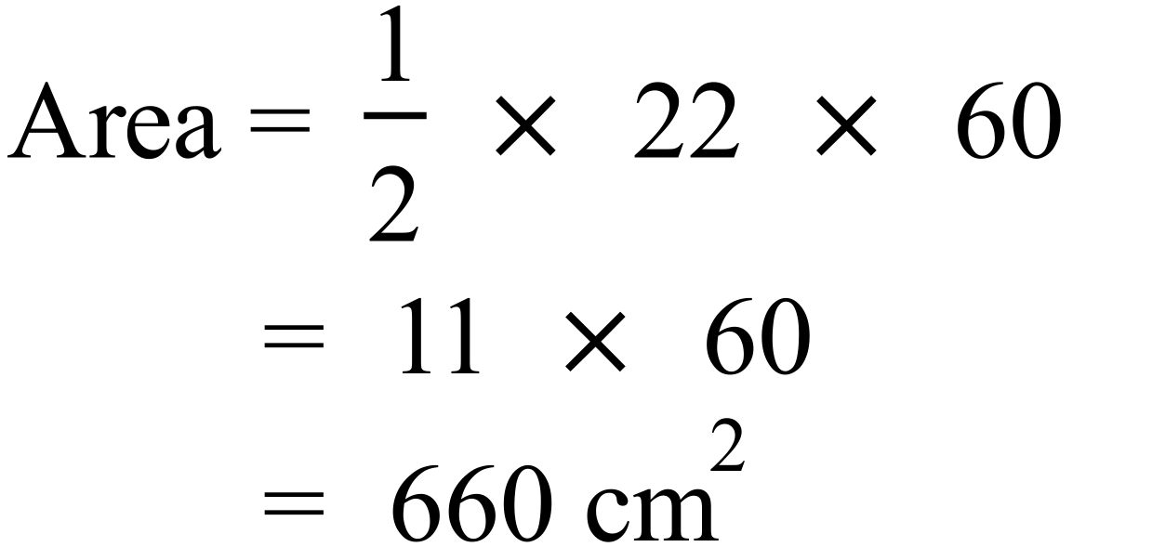 |  | 660 cm²
 | 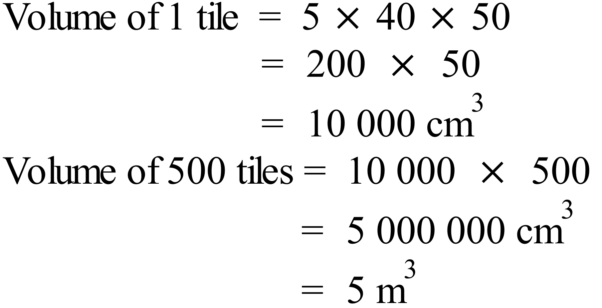 |  | 5 m³
 | Distance through W = 60 + 80 = 140 m  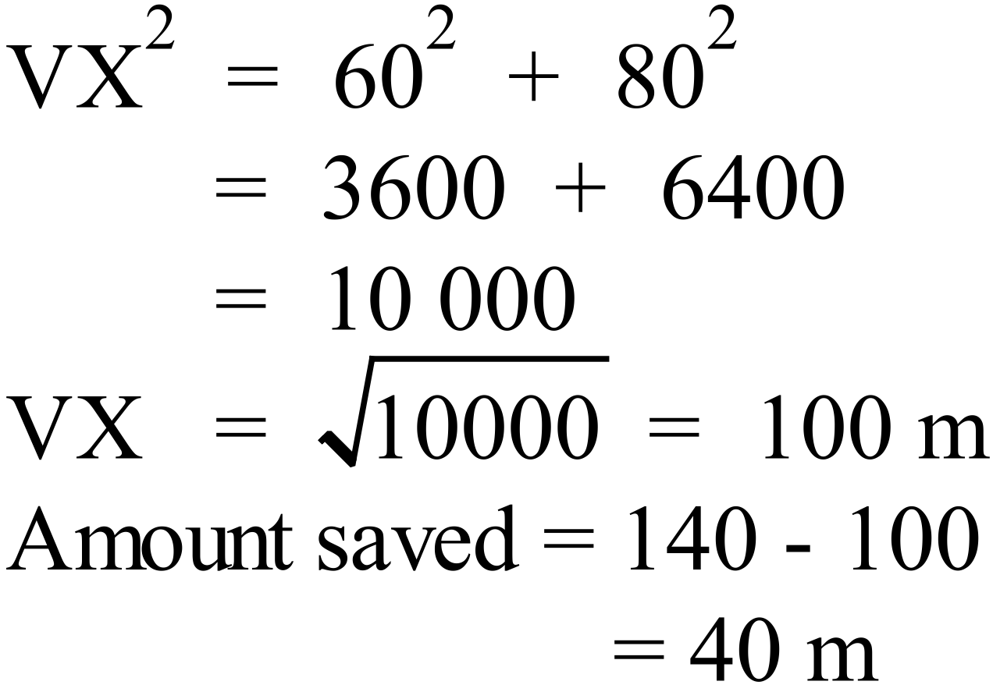 |  | 40 m
 |  |  | ab + 15a
 | 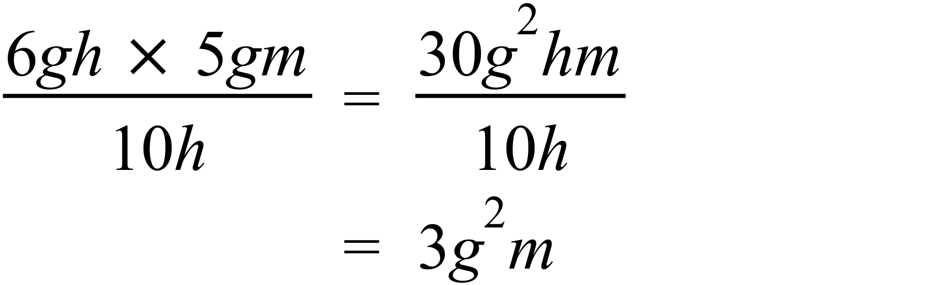 |  | 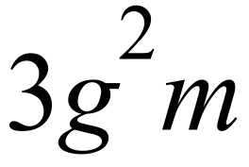
 |  |  | 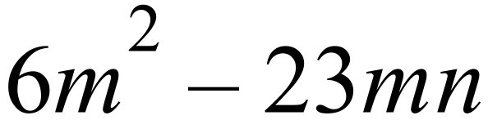
 | 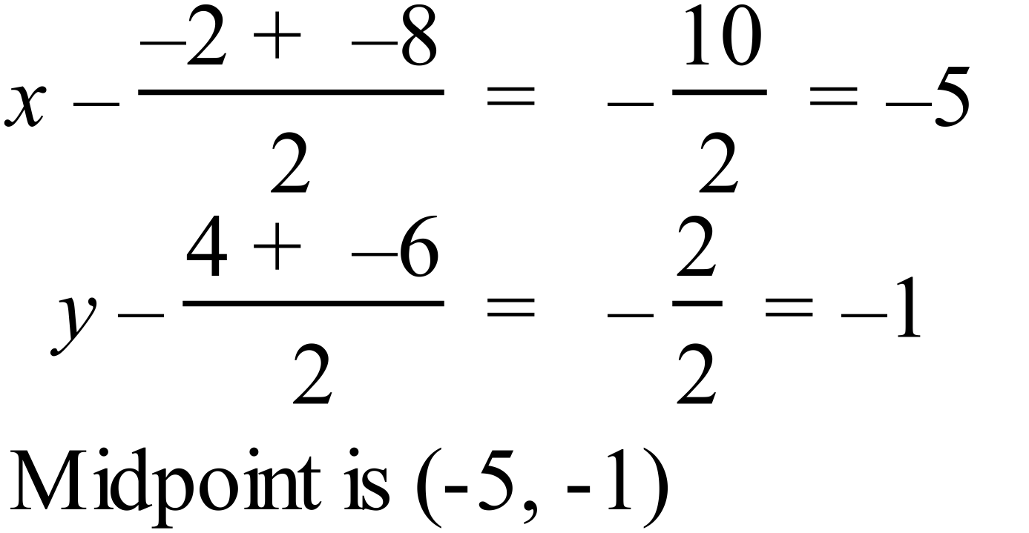  Or by using the number plane diagram. |  | 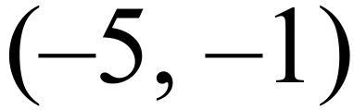
 | 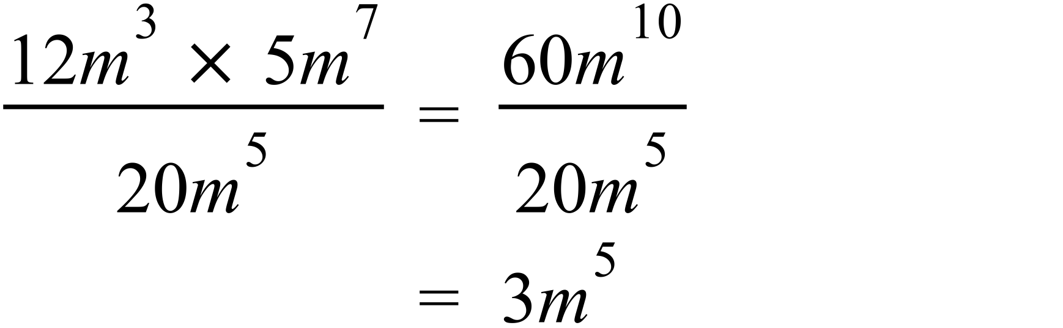 |  | 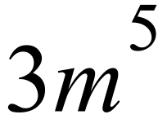
 | 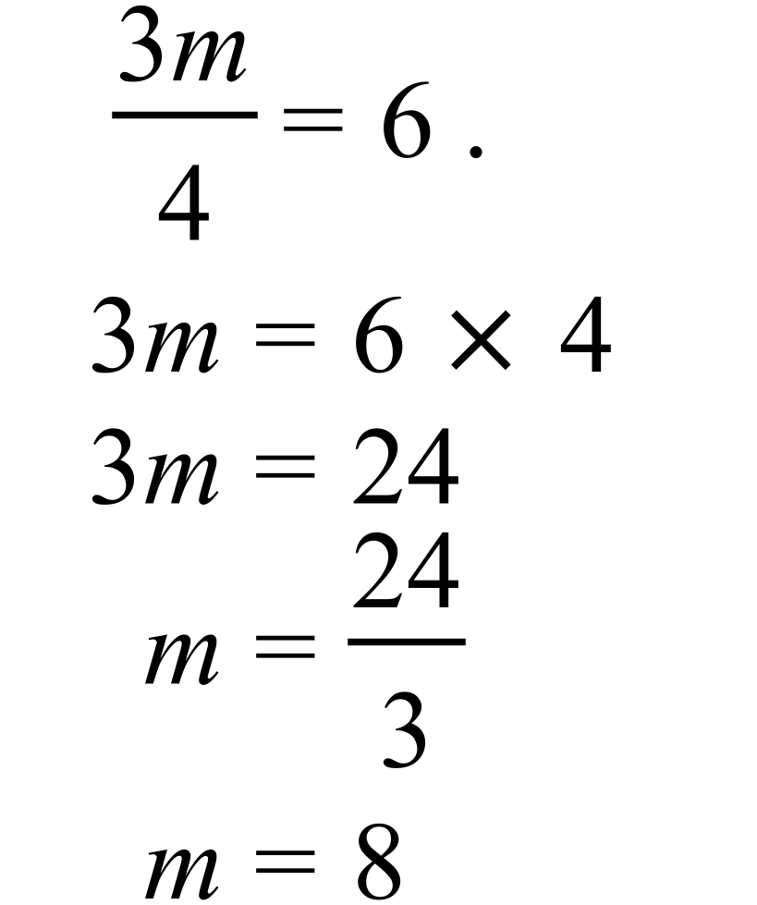 |  | m = 8
 | Number of marbles = 19 + 16 + 5 = 40  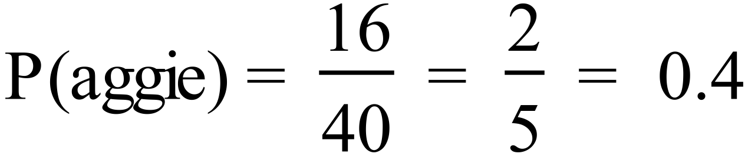 |  | 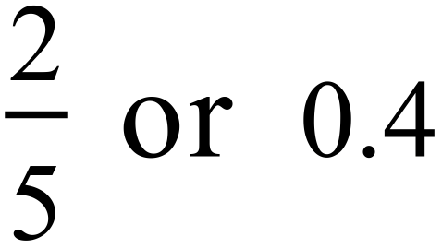
 | Arrange in order.  0.87, 0.95, 1.24, 1.32, 1.35, 1.45, 1.65, 1.75, 1.84, 1.88.  Middle two of 10 are 1.35 and 1.45.  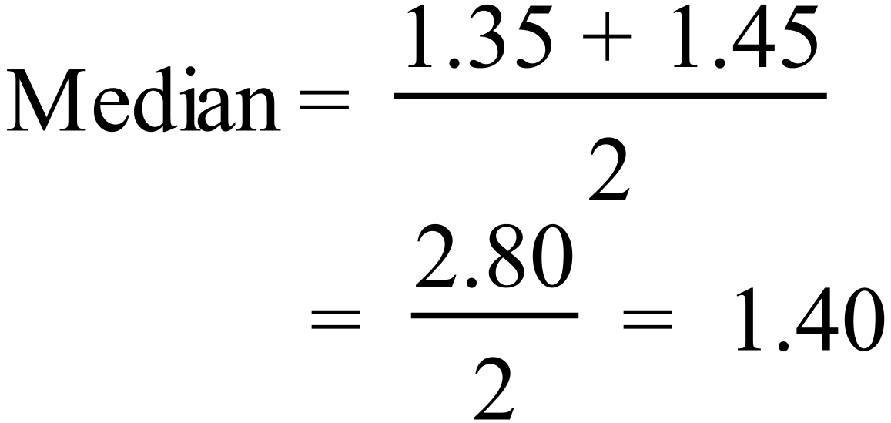 |  | 1.40 m
 | Between 1985 and 1987 the increase was $1 600 which was the biggest. |  | 1985 and 1987
 | Current record is 6.0 (in 2003)  Increase of 10% = 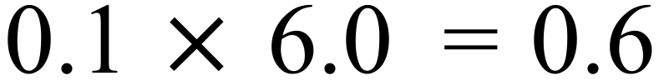  So need to make 6.6  In 2015 profit was 5.2, so increase compared to 2015 is  6.6 – 5.2 = 1.4 so $1 400. |  | $1 400

Year 10 |  | WME Half Yearly Advanced Maths | Calculator Allowed
Section 2 Part A Multiple Choice Section
ANSWERS
No. | WORKING |  |  | ANSWER
 | 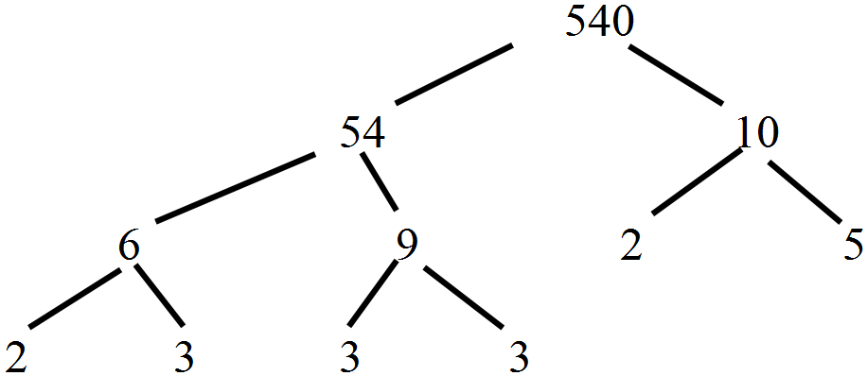  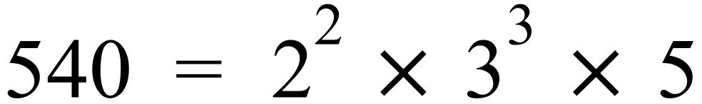 |  |  | A
 | Sales over $4000 = $2500.  Commission =  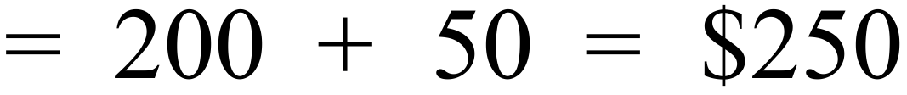  Pay for week = 700 + 250 = $950 |  |  | C
 | 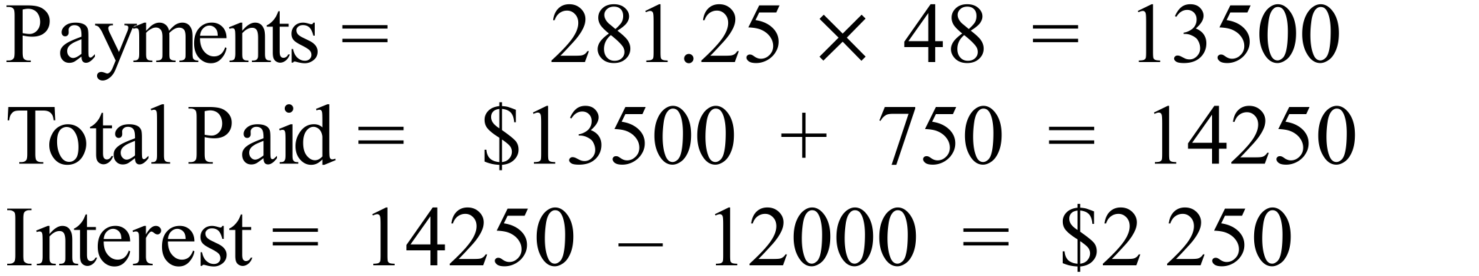 |  |  | D
 | 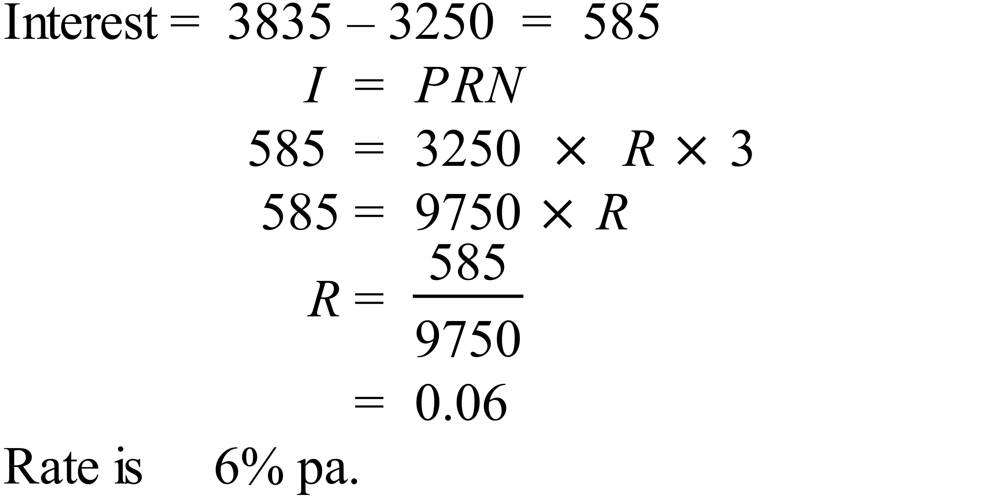 |  |  | B
 | 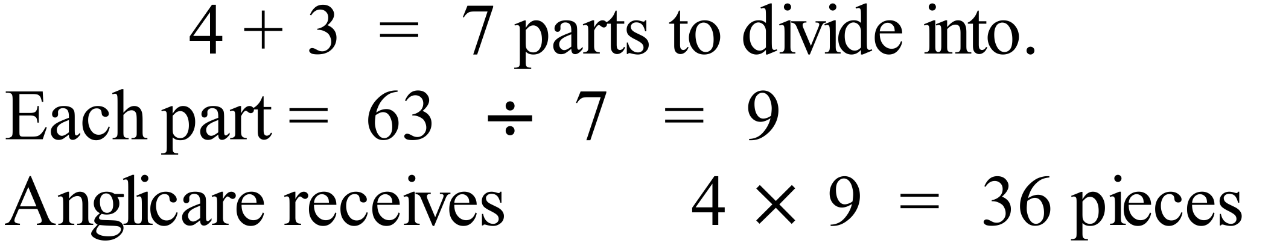 |  |  | D
 | 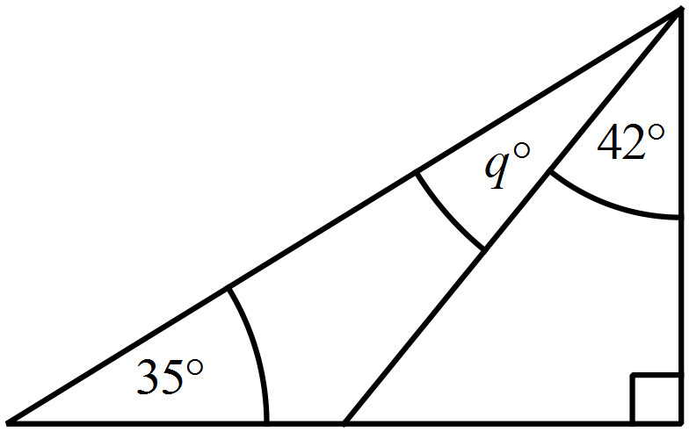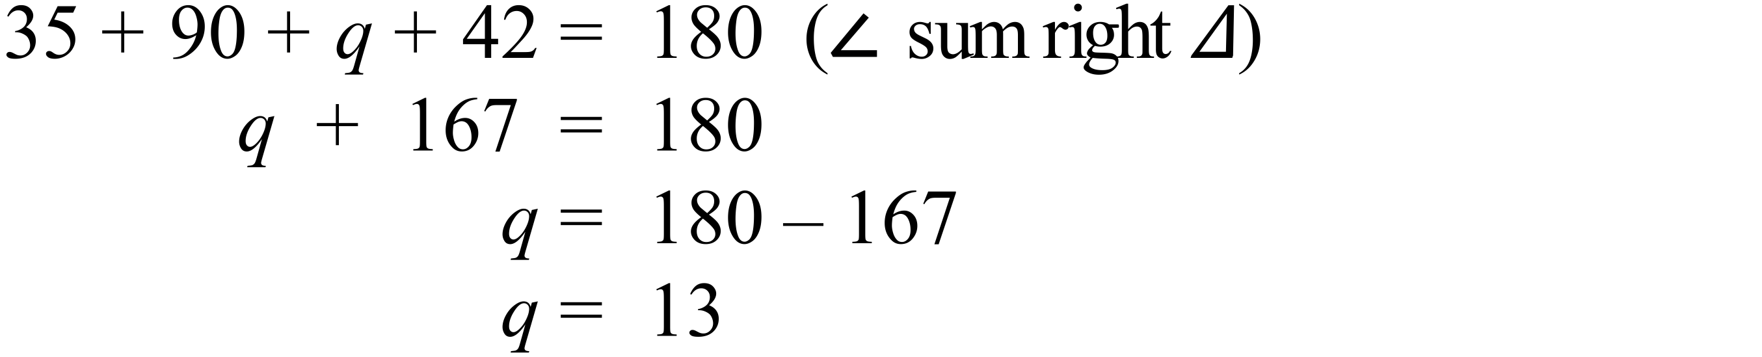 |  |  | A
 | 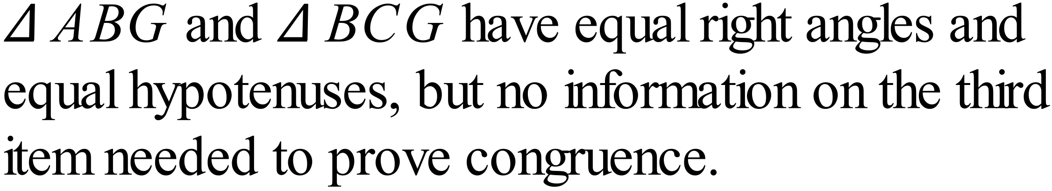 |  |  | B
 | Although a quadrilateral is present, it’s angle sum is not used in this proof. |  |  | B
 | 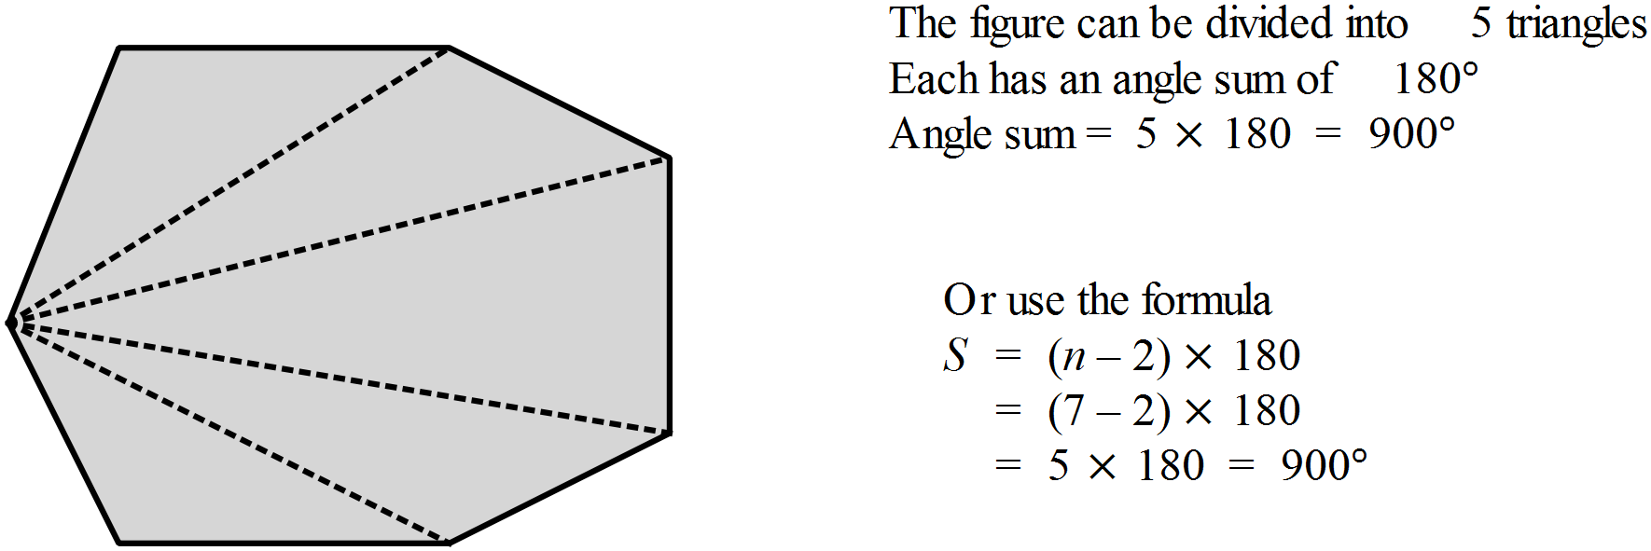 |  |  | C
 | 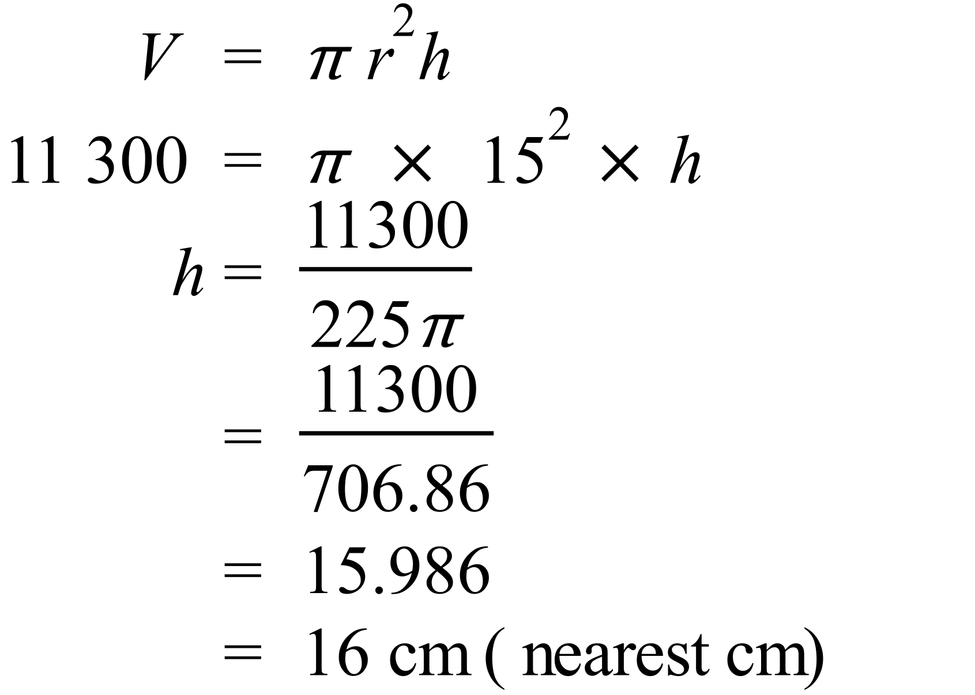 |  |  | C
 | 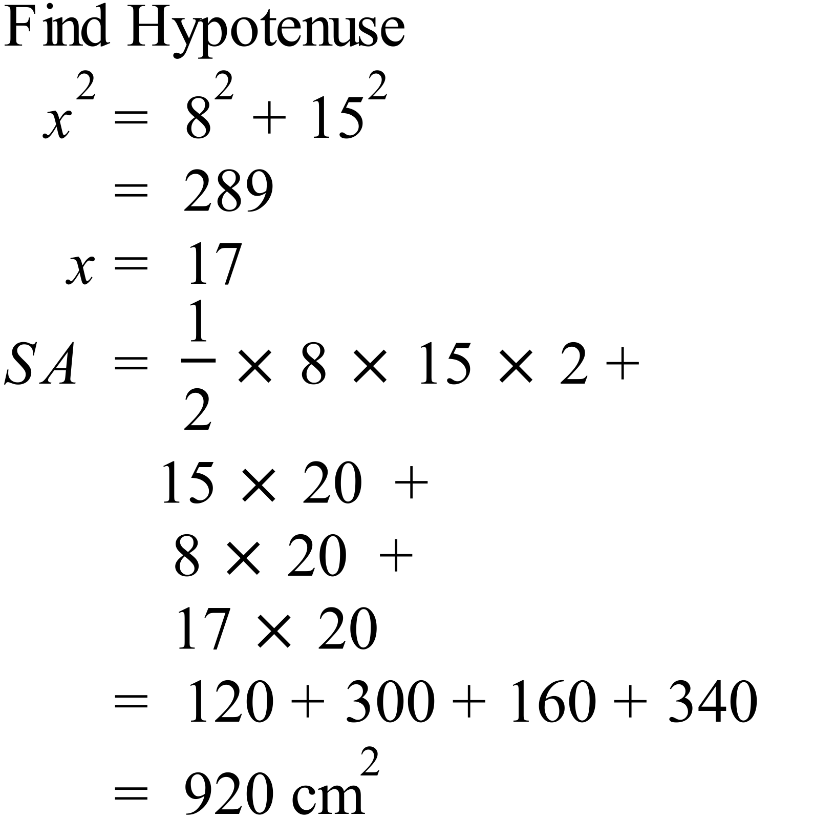 |  |  | D
 | 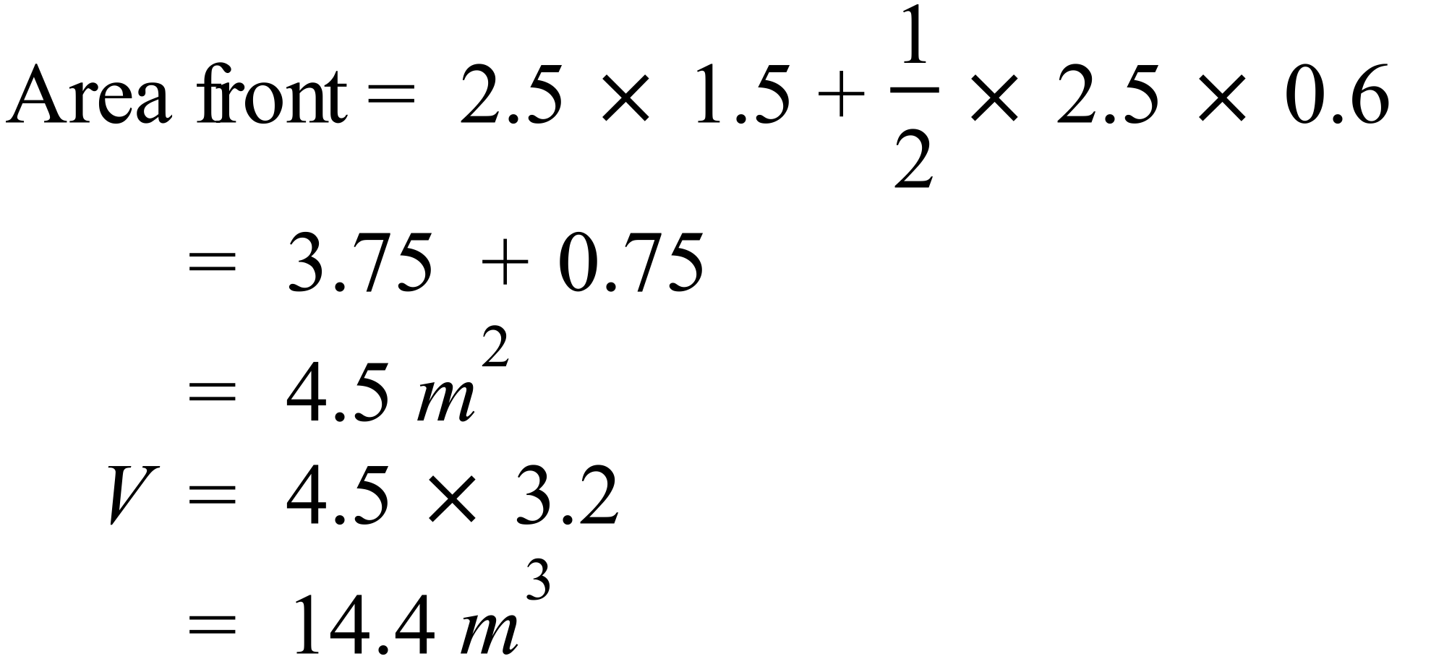 |  |  | C
 | 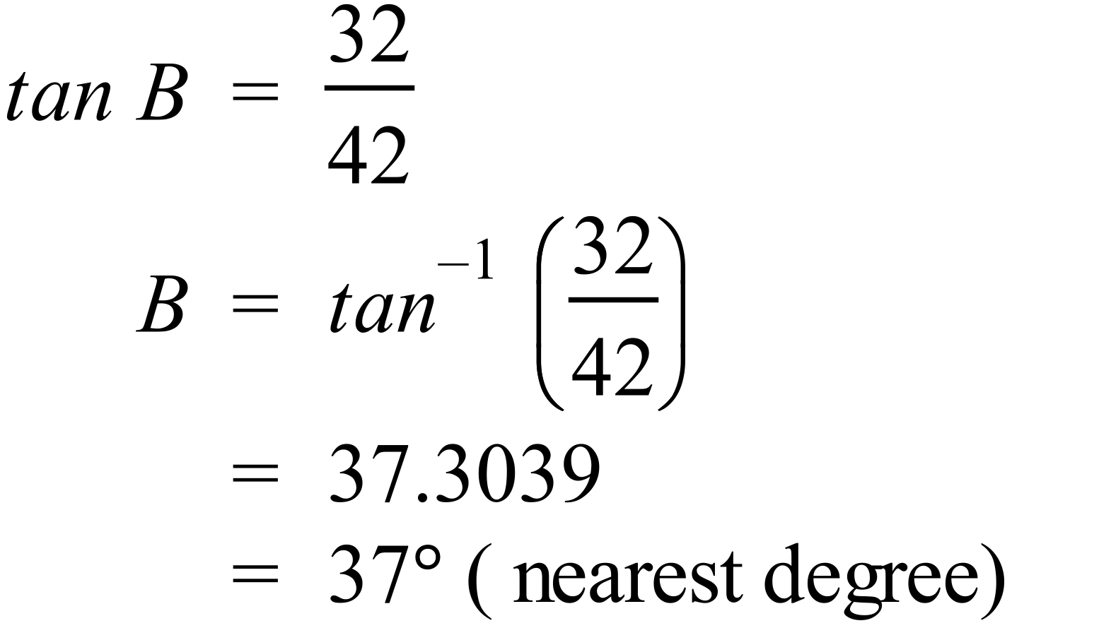 |  |  | A
 | 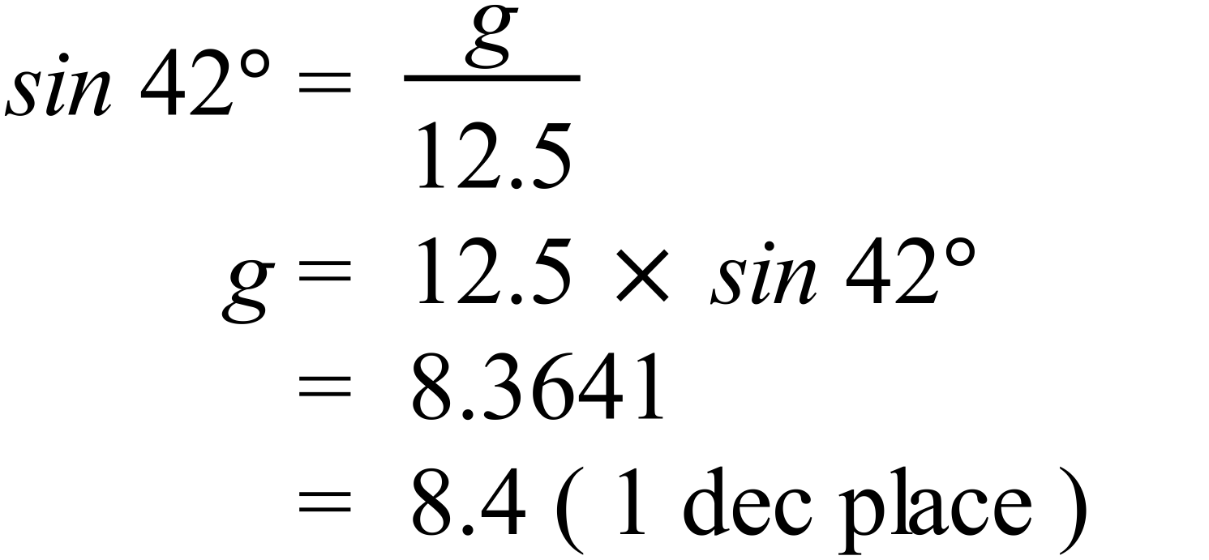 |  |  | A
 | 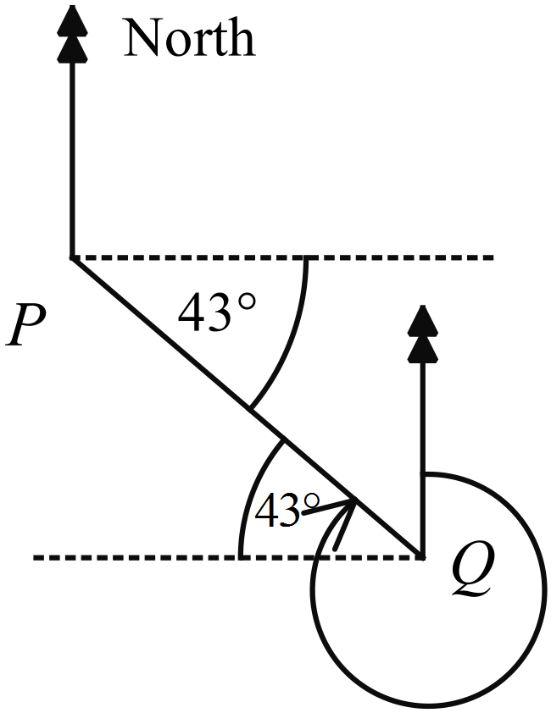Bearing of P from Q  is 270º + 43º = 313º |  |  | D
 | 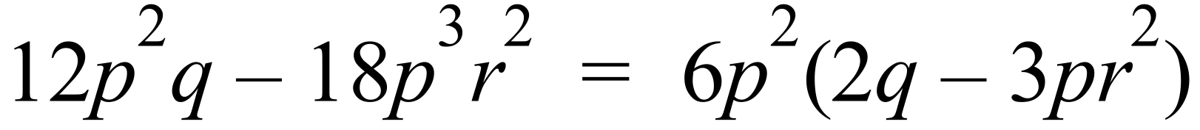 |  |  | D
 | 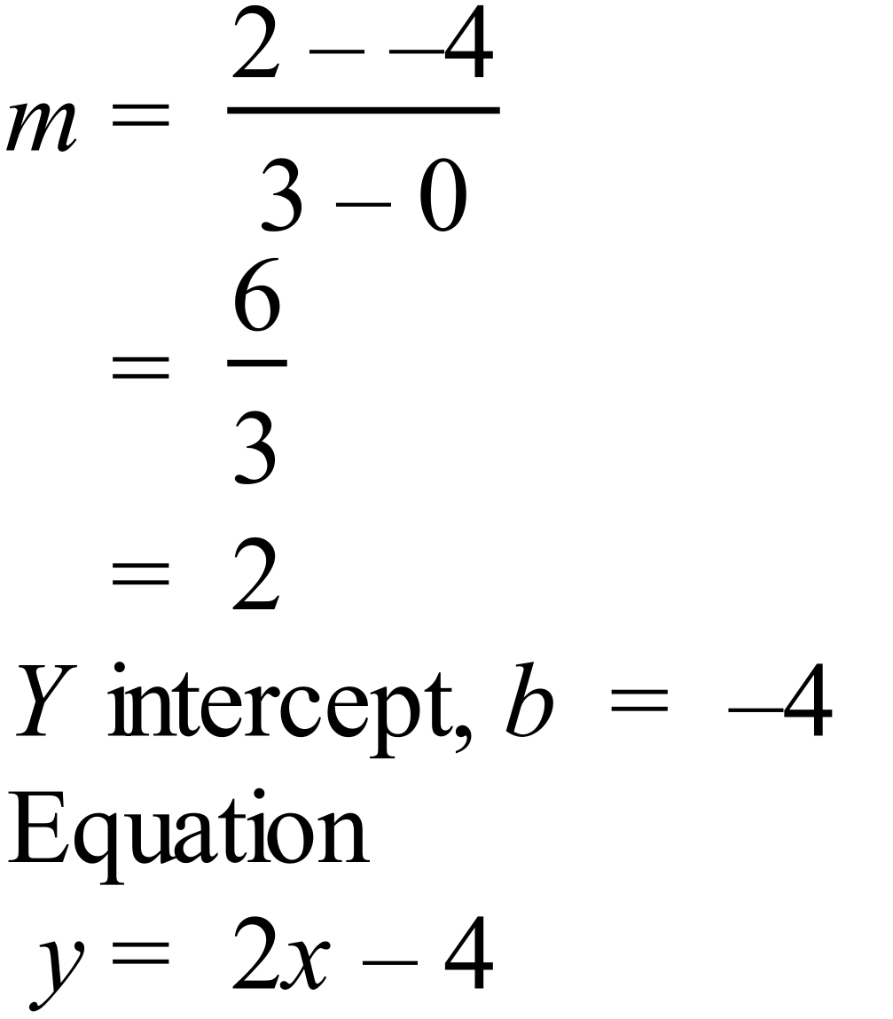 |  |  | C
 | 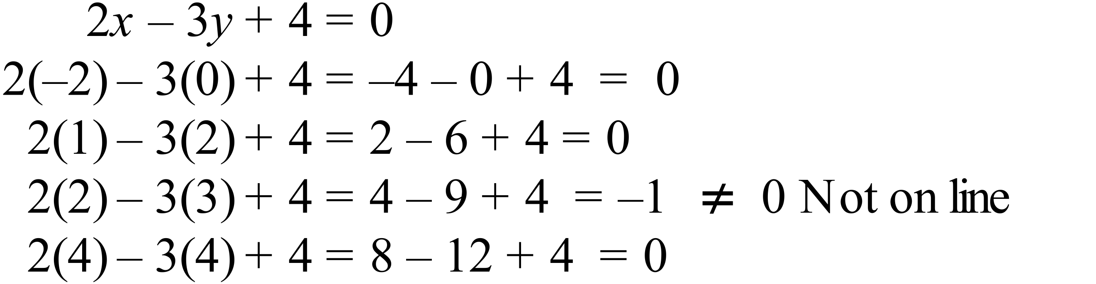 |  |  | C
 | 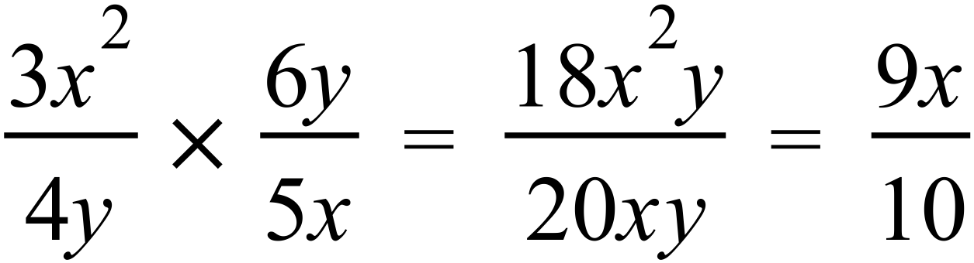 |  |  | B
 | 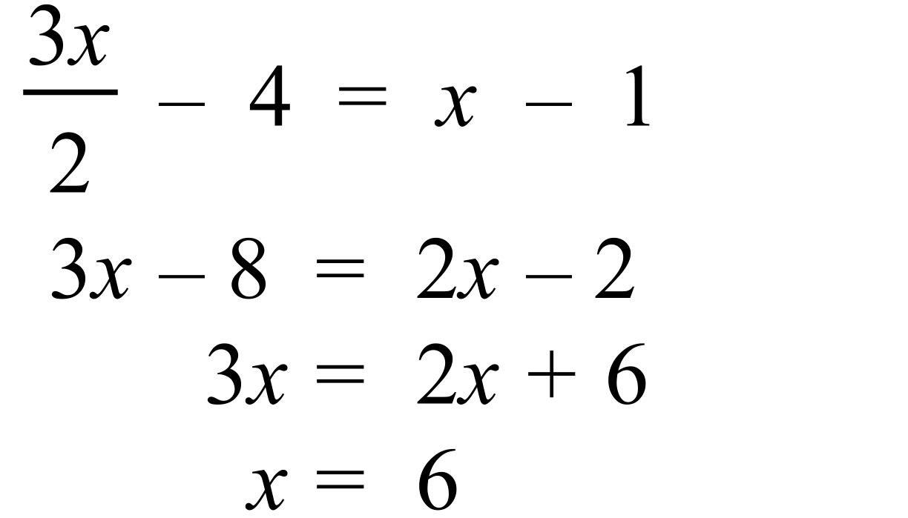 |  |  | B
 | Counting the leaves there are 21 scores.  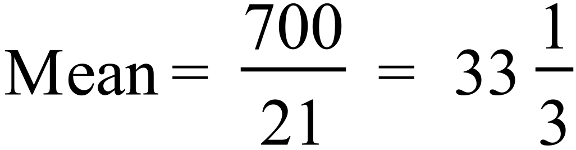 |  |  | B
 | Median is the middle number of 21 ( the 11th) which is 33. |  |  | A
   |  |  |  |  | 1 | 1 | 4 | 6
   |  |  |  |  | 2 | 2 | 5 | 6 | 7 | 8
   |  |  |  |  | 3 | 0 | 2 | 3 | 5 | 6 | 6 | 9
   |  |  |  |  | 4 | 2 | 4 | 7 | 9
   |  |  |  |  | 5 | 3 | 5
 | Middle of lower 10 scores is between 25 and 26 so 25.5  Middle of upper 10 scores is between 42 and 44 so 43  Interquartile range = 43 – 25.5 = 17.5 |  |  | A
   |  |  |  |  | 1 | 1 | 4 | 6
   |  |  |  |  | 2 | 2 | 5 | 6 | 7 | 8
   |  |  |  |  | 3 | 0 | 2 | 3 | 5 | 6 | 6 | 9
   |  |  |  |  | 4 | 2 | 4 | 7 | 9
   |  |  |  |  | 5 | 3 | 5
 | The distribution is bimodal and symmetrical. |  |  | A
 | As it is symmetrical the median and the mean are the same (at 23), as it is bimodal the mode is different (22 and 24), and the range of 6 is different again. |  |  | D
 | P = 2500, r = 0.064, n = 5.  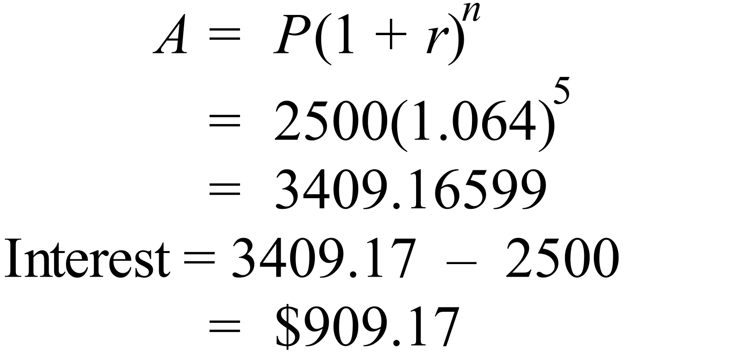 |  |  | B
 | 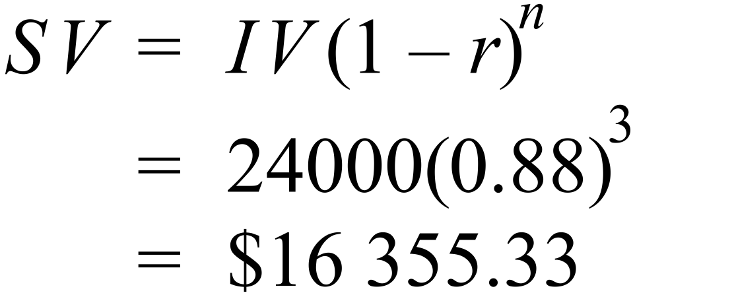 |  |  | C
 | 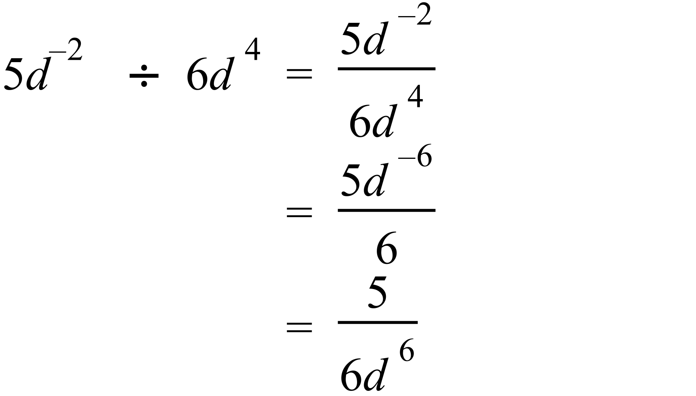 |  |  | A
 | 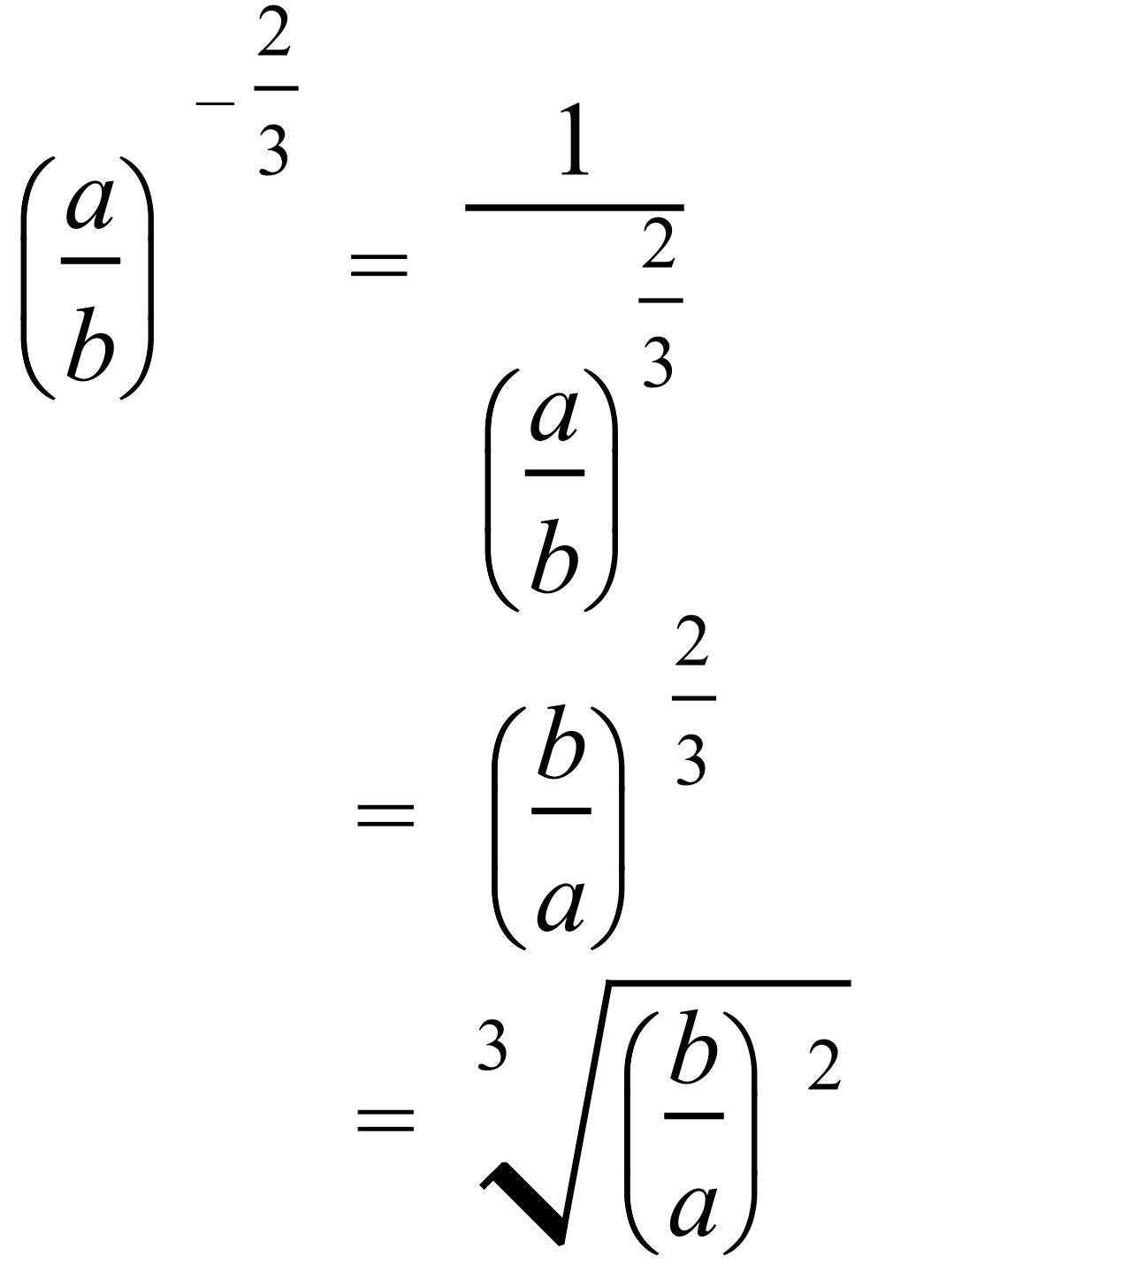 |  |  | D
 | 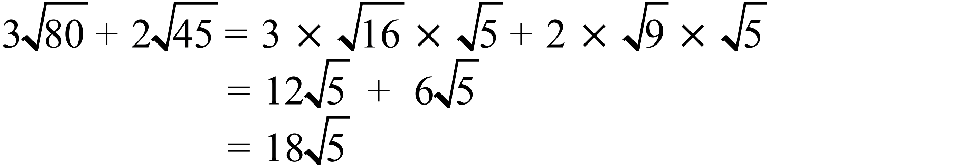 |  |  | B
 | 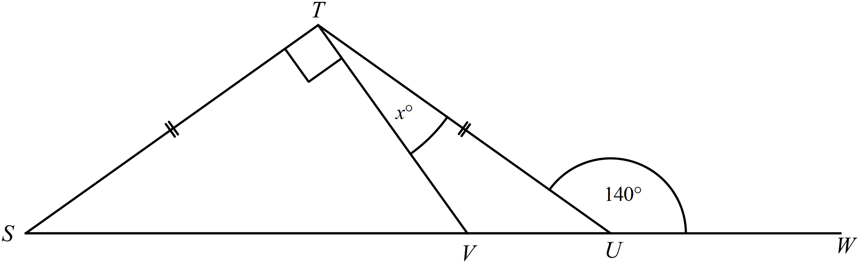  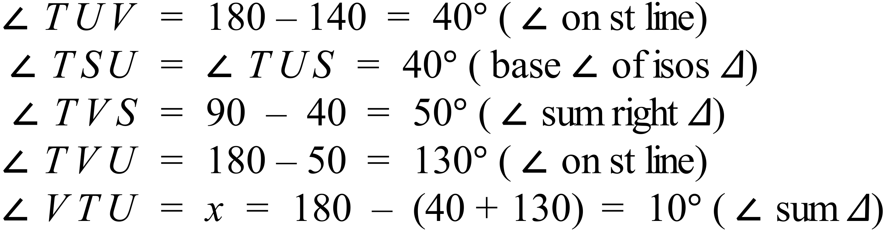 |  |  | A
 | 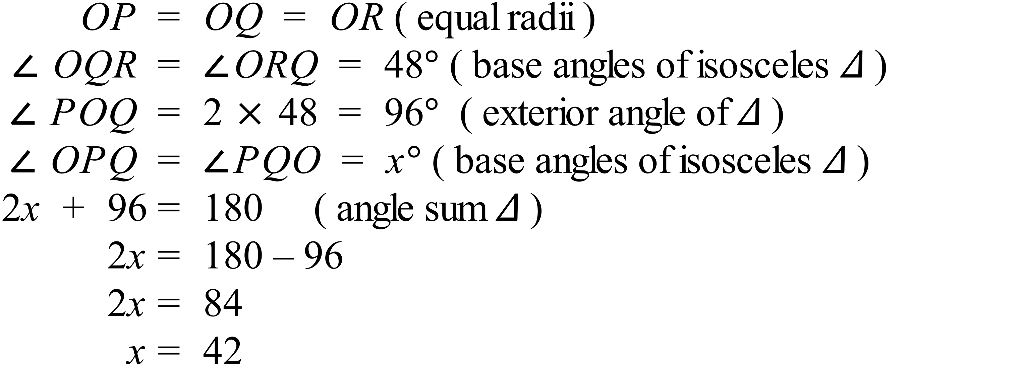 |  |  | C
 | 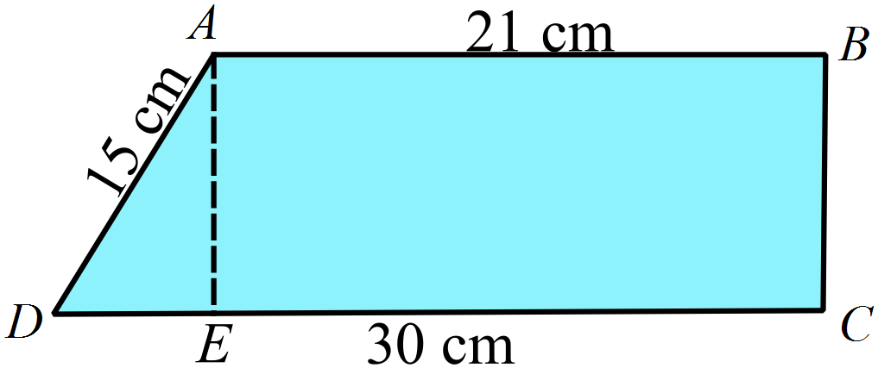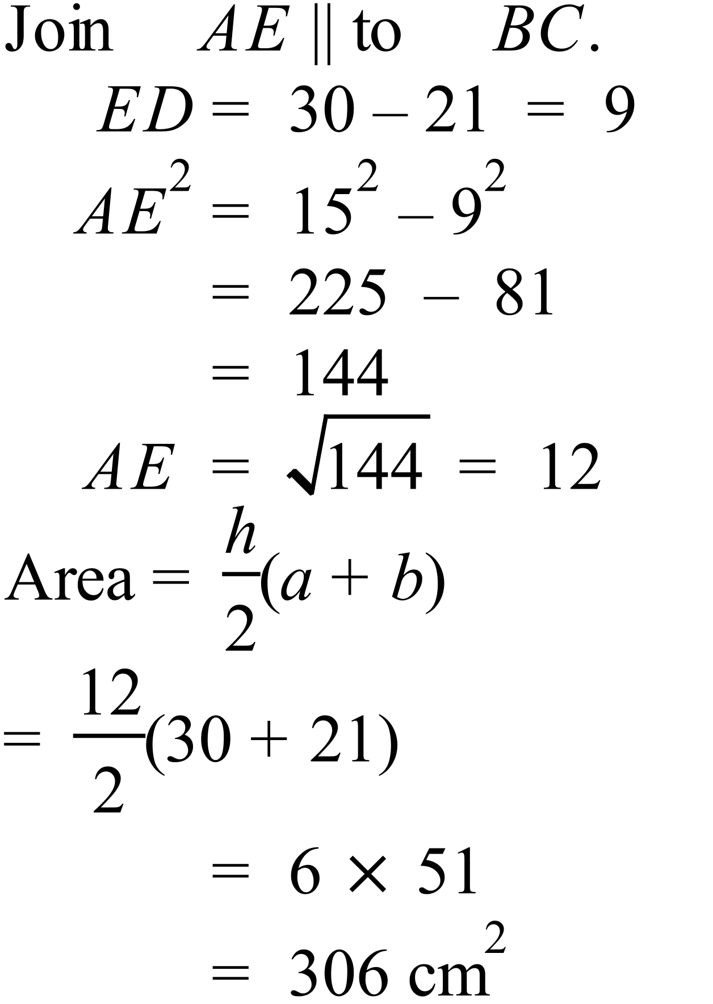 |  |  | A
 | 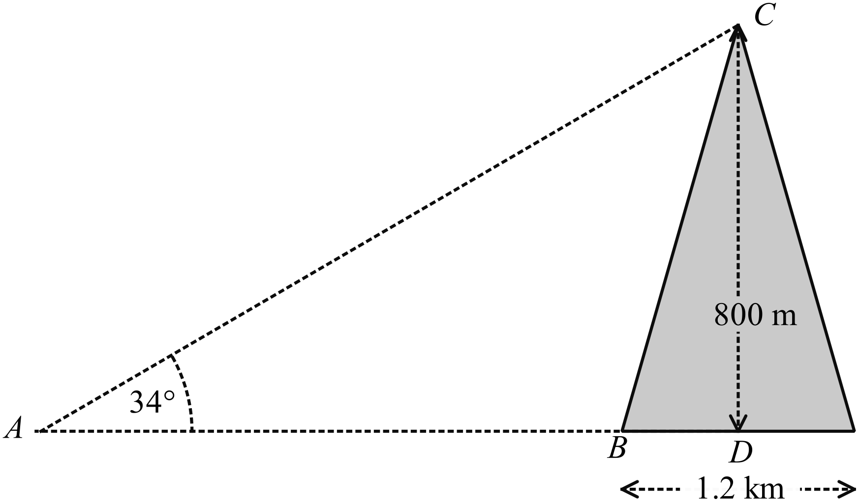  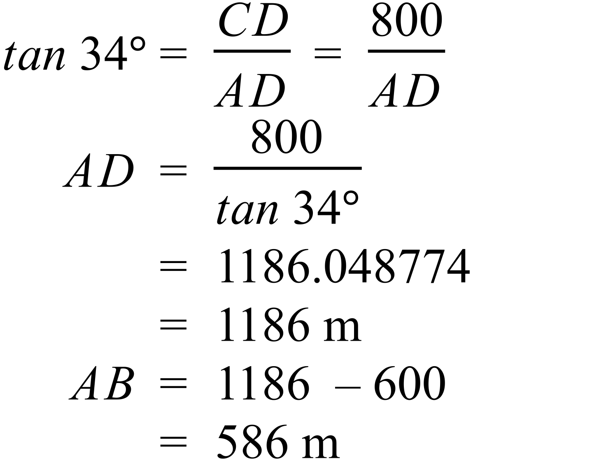 |  |  | B
 | 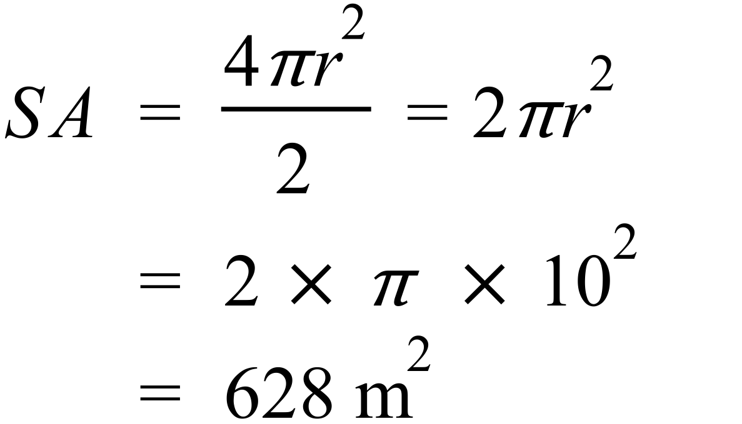 |  |  | C
 | 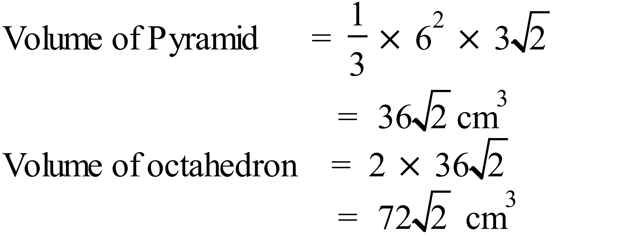 |  |  | C
 | 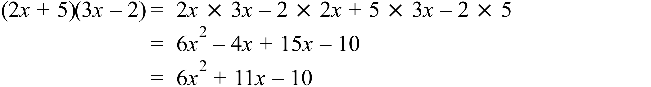 |  |  | D
 | 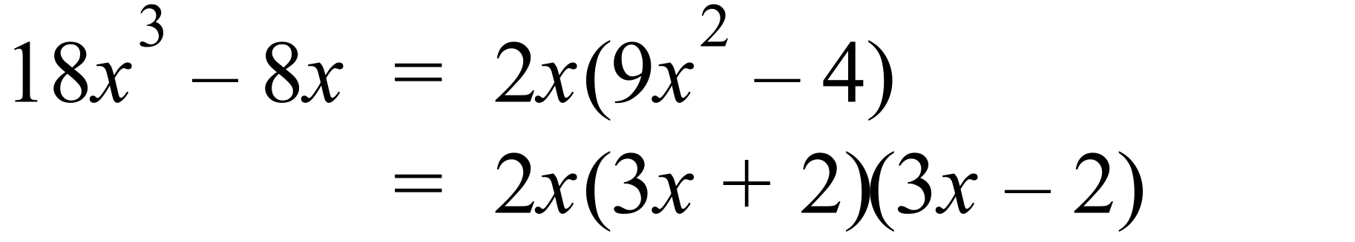 |  |  | D
 | 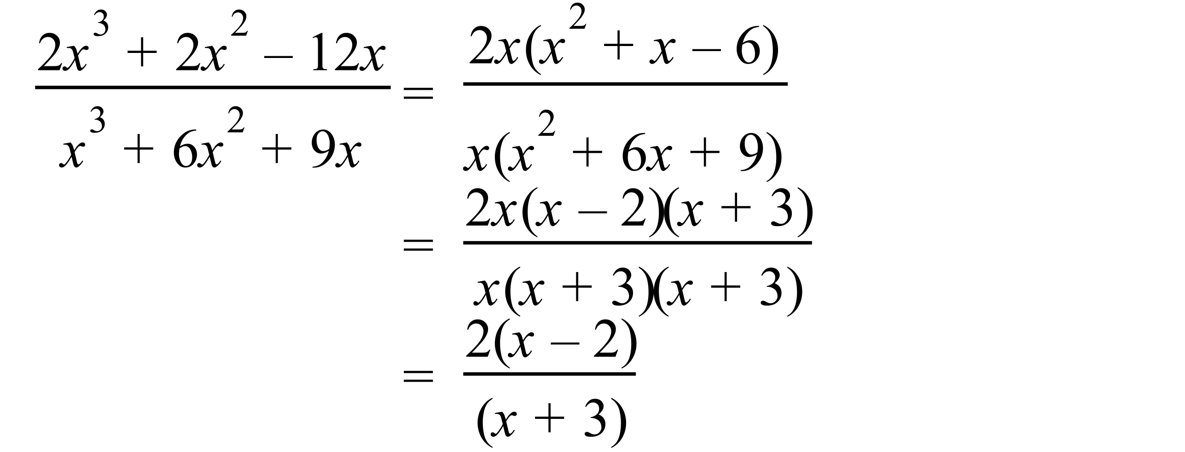 |  |  | B
 | 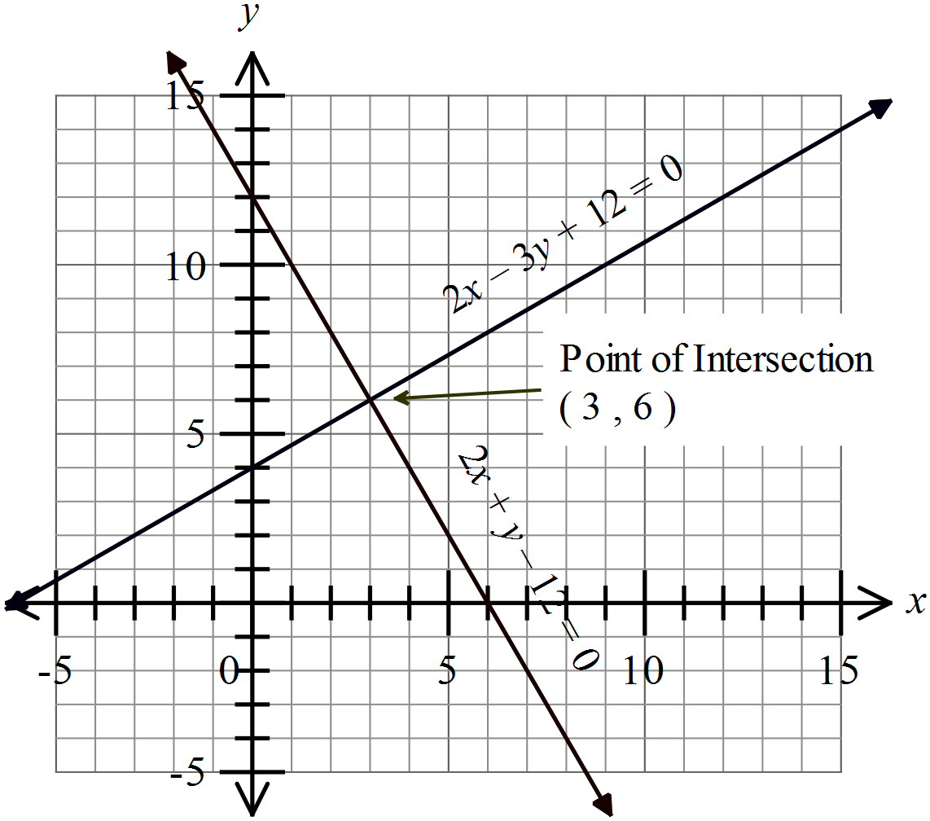  Or solve the equations algebraically. |  |  | B
 | 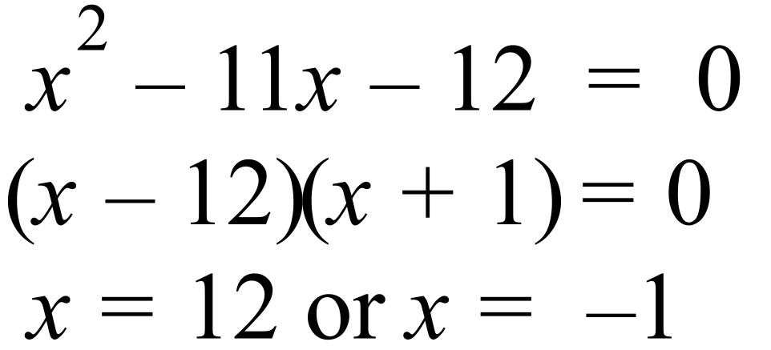 |  |  | A
 | 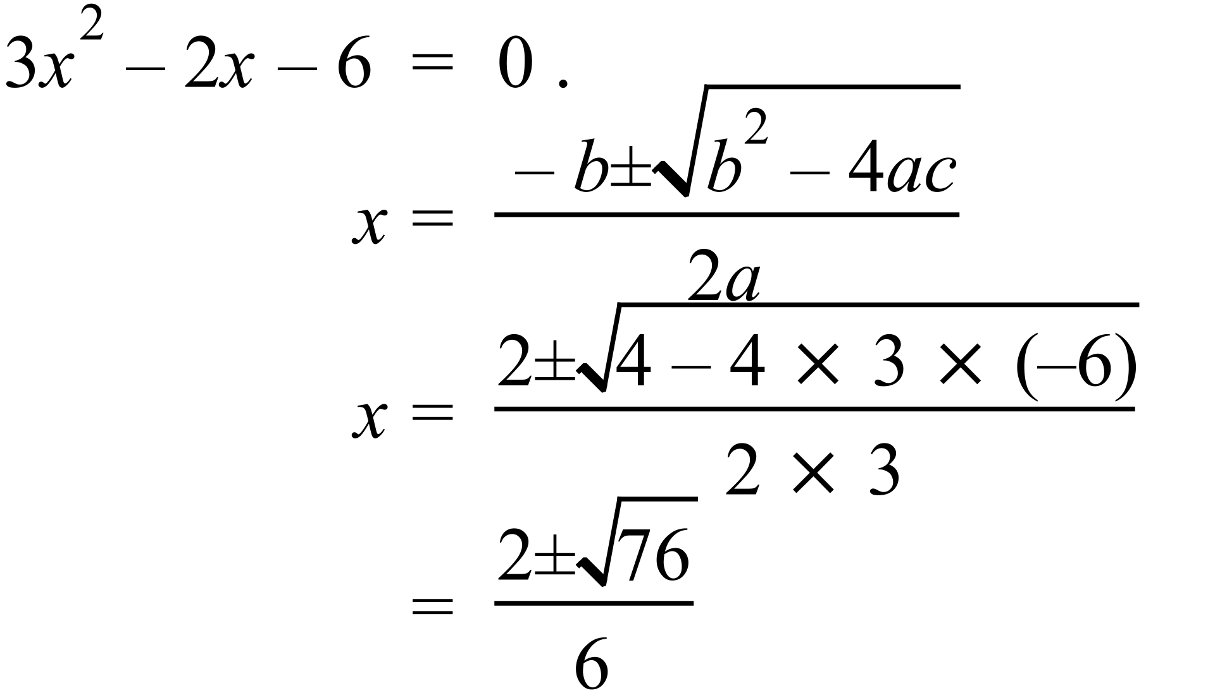 |  |  | D
 | After 15 min and again after 85 min.  10: 50am + 15 min = 11:05 am  10:50 + 85 min = 11:50+25 min = 12:15 pm |  |  | A
 | The quick drop in air pressure at the start indicates a quick climb, the level section indicates it stays at the same altitude for around an hour and the less steep rise in air pressure indicates a more gradual descent, so D best describes this. |  |  | D
 | The exponential approaches zero as x approaches negative infinity and increases without bound as x approaches positive infinity and crosses the y axis at 1.  C describes this |  |  | C
 | 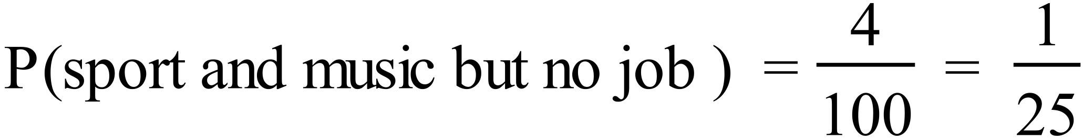 |  |  | A
 | 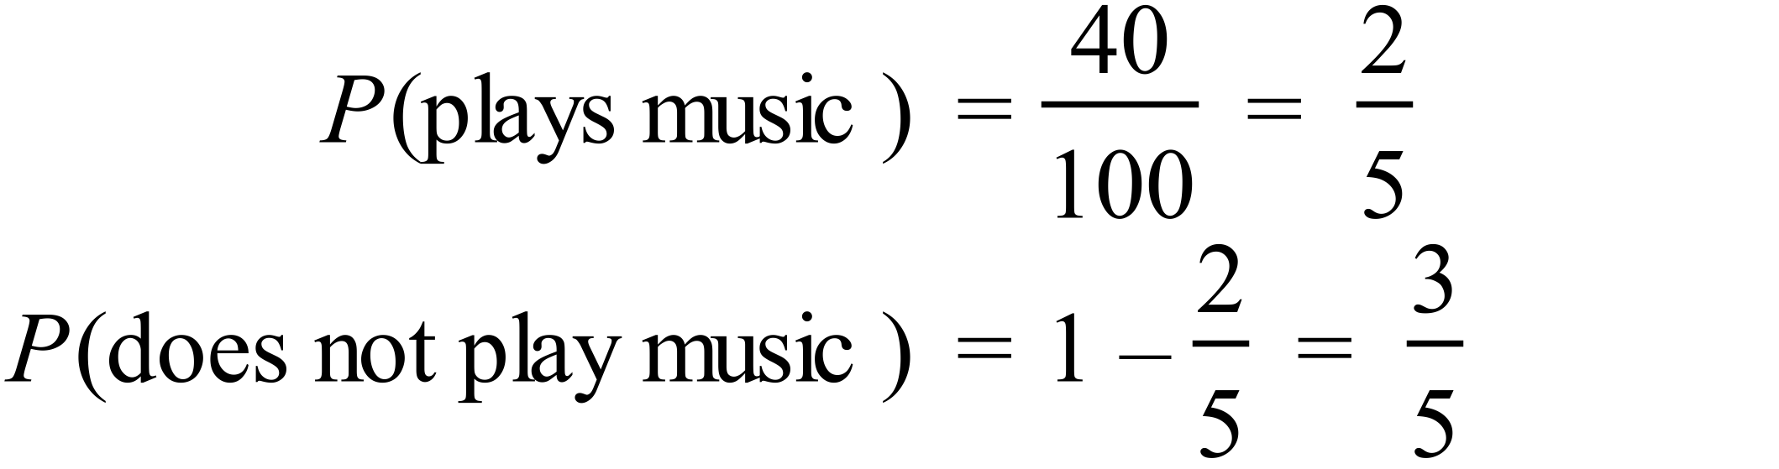 |  |  | C
 | 1.5 is the lower quartile and 1.95 is the upper extreme, so 75% of heights are between these values.  75% of 200 = 150 |  |  | D
 | From a calculator 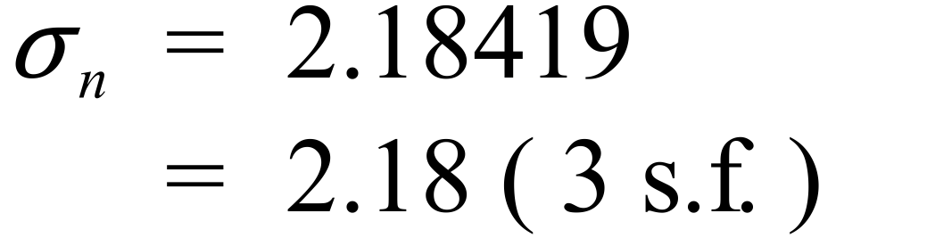 |  |  | B
 | The means are not significantly different so A is correct.  The Berries have a higher SD, so will have more very high scores and more very low scores, The Bears will have more scores in the middle, so B and C are correct, but D is not. |  |  | D

High School
Half Yearly Exam
Mathematics Course
Multiple Choice Section Answer Sheet
Name ________________________________ Teacher ________________________

Completely fill the response oval representing the most correct answer.

26. A B C D
27. A B C D
28. A B C D
29. A B C D
30. A B C D
31. A B C D
32. A B C D
33. A B C D
34. A B C D
35. A B C D
36. A B C D
37. A B C D
38. A B C D
39. A B C D
40. A B C D
41. A B C D
42. A B C D
43. A B C D
44. A B C D
45. A B C D
46. A B C D
47. A B C D
48. A B C D
49. A B C D
50. A B C D

51. A B C D
52. A B C D
53. A B C D
54. A B C D
55. A B C D
56. A B C D
57. A B C D
58. A B C D
59. A B C D
60. A B C D
61. A B C D
62. A B C D
63. A B C D
64. A B C D
65. A B C D
66. A B C D
67. A B C D
68. A B C D
69. A B C D
70. A B C D
71. A B C D
72. A B C D
73. A B C D
74. A B C D
75. A B C D

Year 10 |  | WME Half Yearly Advanced Maths | Calculator Allowed
Section 2 Part B Longer Answer Section
ANSWERS
 |  |  | Marks
76. | 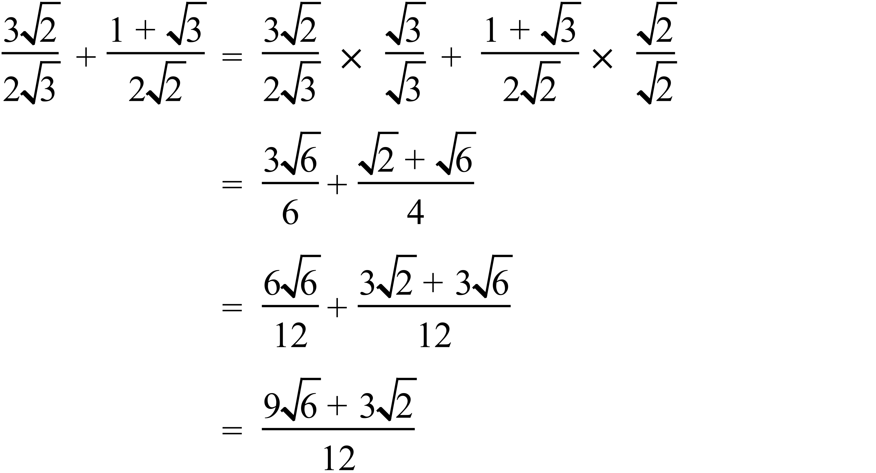 |  | 3 marks for correct answer  2 marks for attempt that includes rationalising and trying to get a common denominator  1 mark for attempt to rationalise or get a common denominator
77. | (a) The radius = 6 cm  By Pythagoras  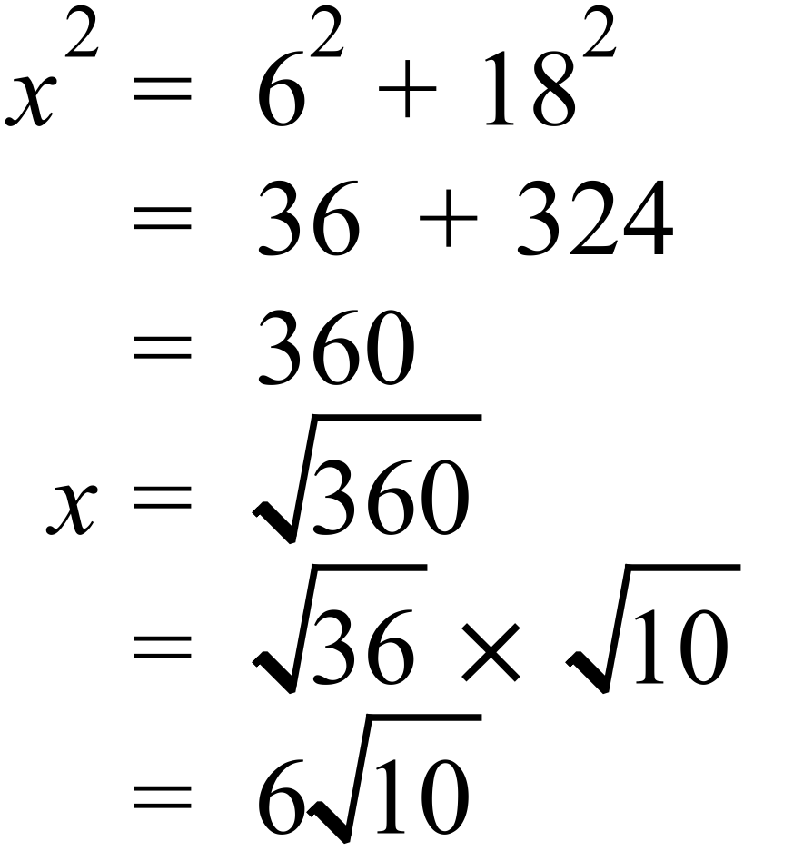 |  | 1 mark for correct working to obtain 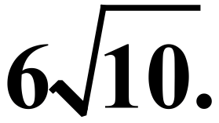
 | (b) 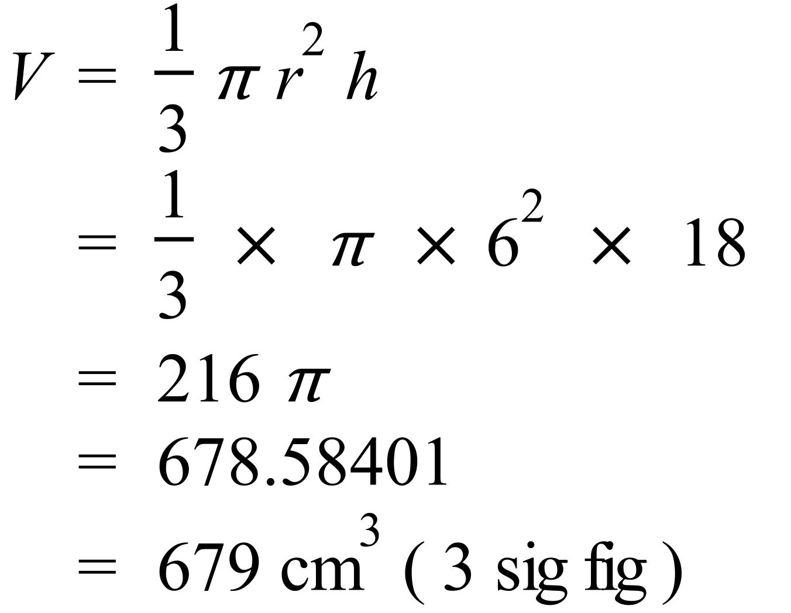 |  | 1 mark for correct answer.
 | (c) 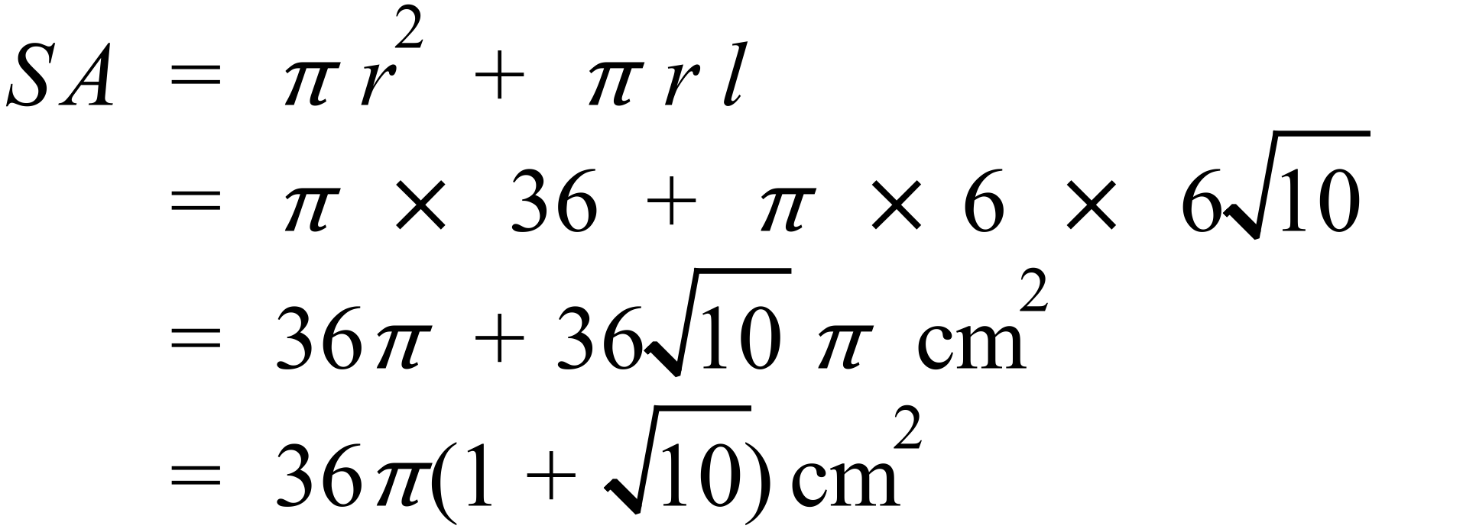 |  | 1 mark for correct answer in either exact form.
78. | (a) 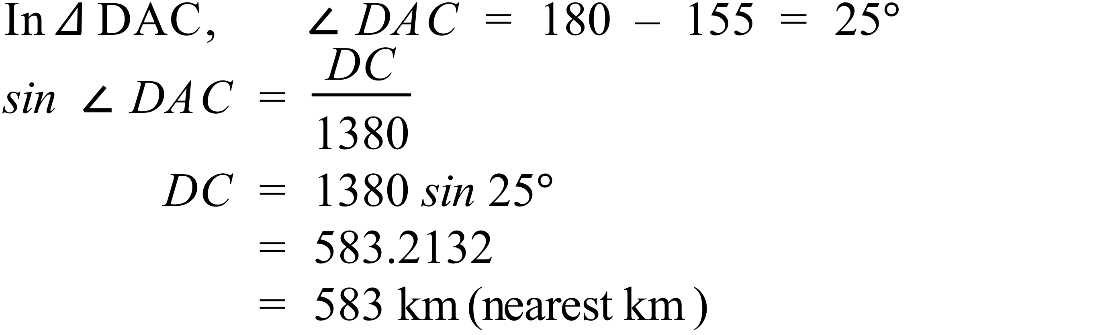 |  | 1 mark for correct answer
 | (b) 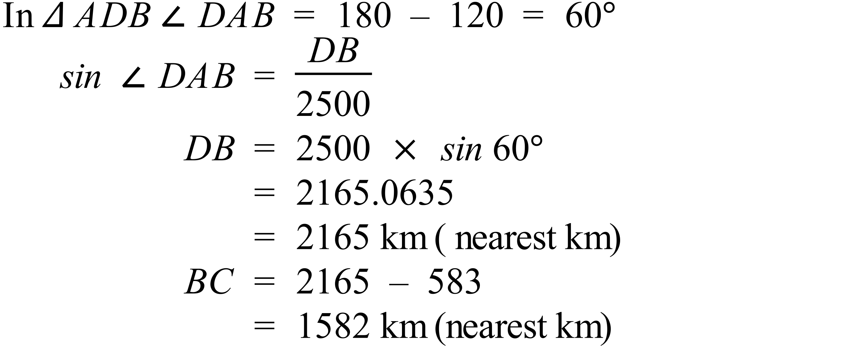 |  | 2 marks for correct answer.  1 mark for an answer which is correct except for a minor calculation error, or using wrong trig ratio, or for an incomplete answer with most relevant calculations completed.
79. | 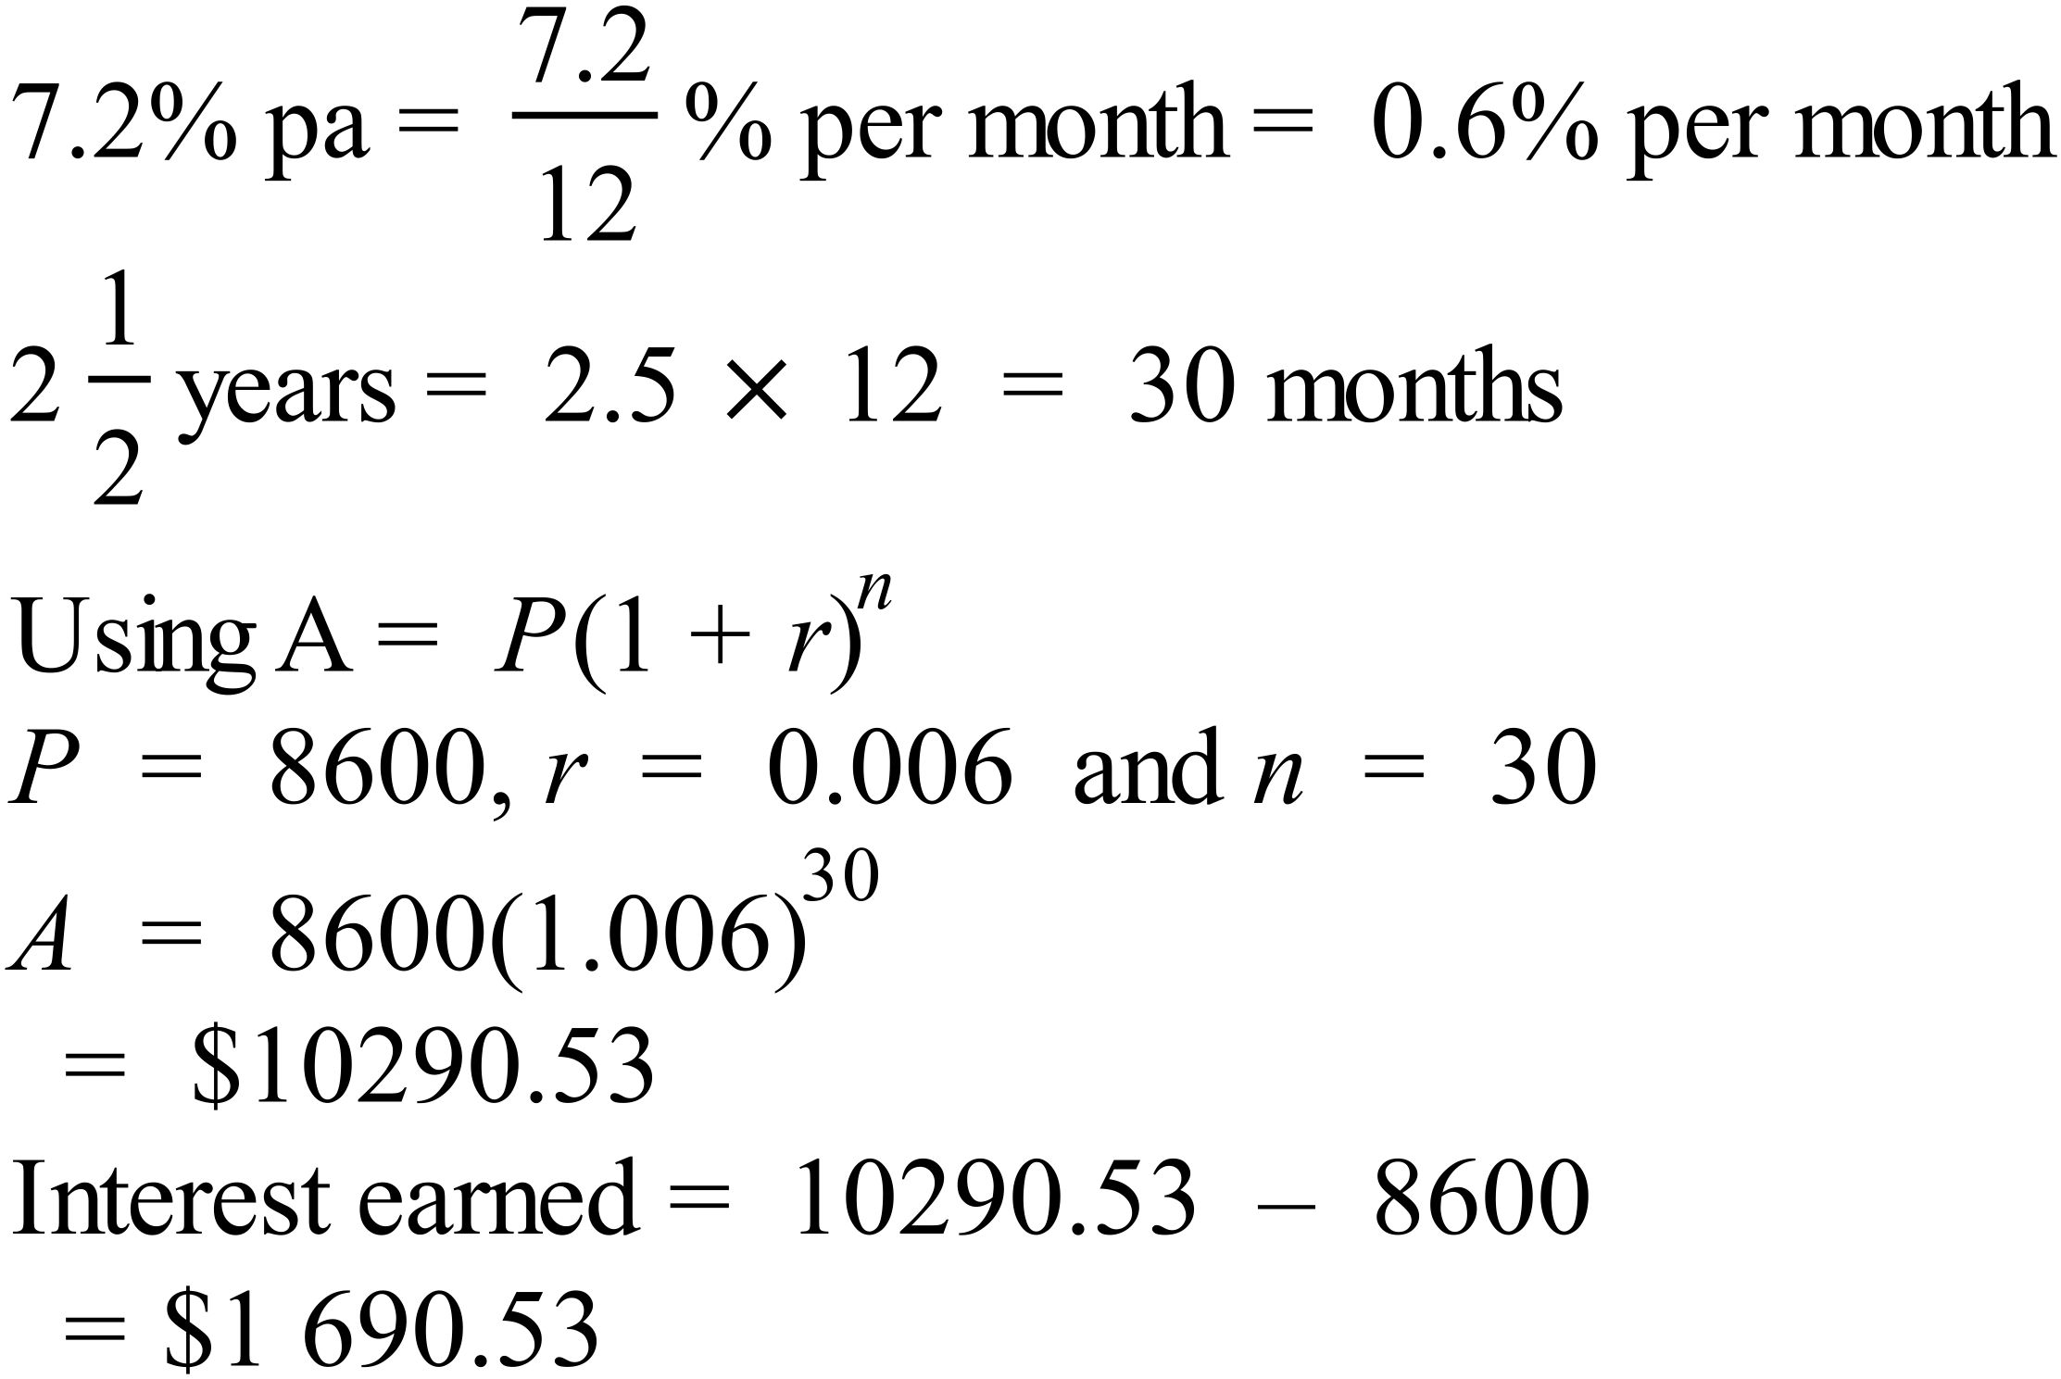 |  | 2 marks for correct answer.  1 mark for an answer which is correct except for a minor calculation error, or substituting wrong value for r or n, or for an incomplete answer with most relevant calculations completed.
80. | (a) 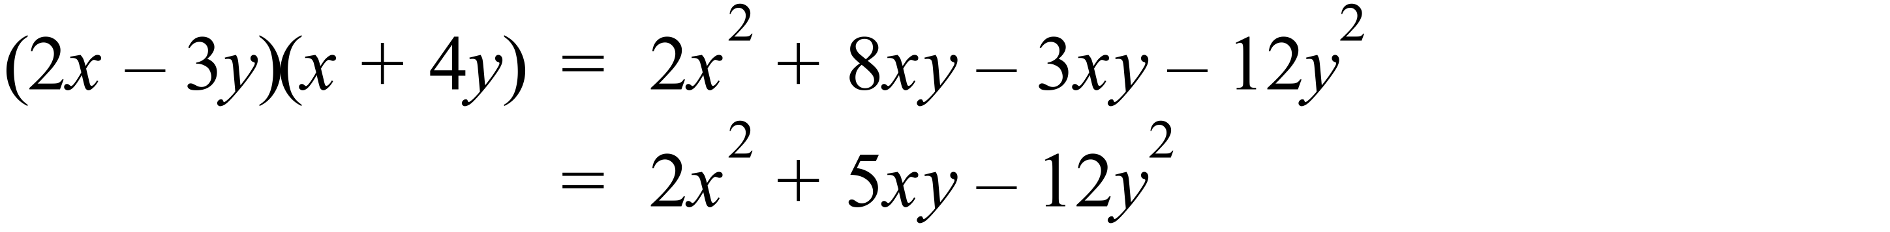 |  | 1 mark for correct answer
 | (b) 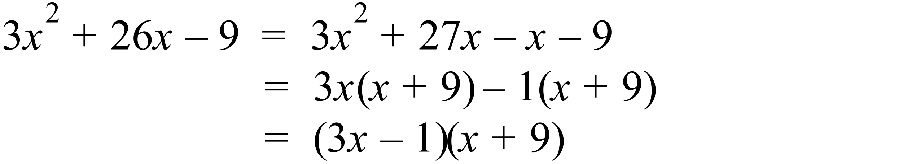 |  | 1 mark for correct answer
 | (c) 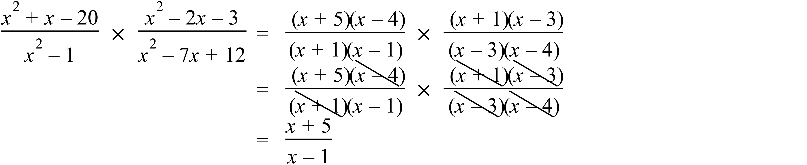 |  | 2 marks for correct answer.  1 mark for an answer which is basically correct except for a minor error in factorising or cancelling.
81. | (a) 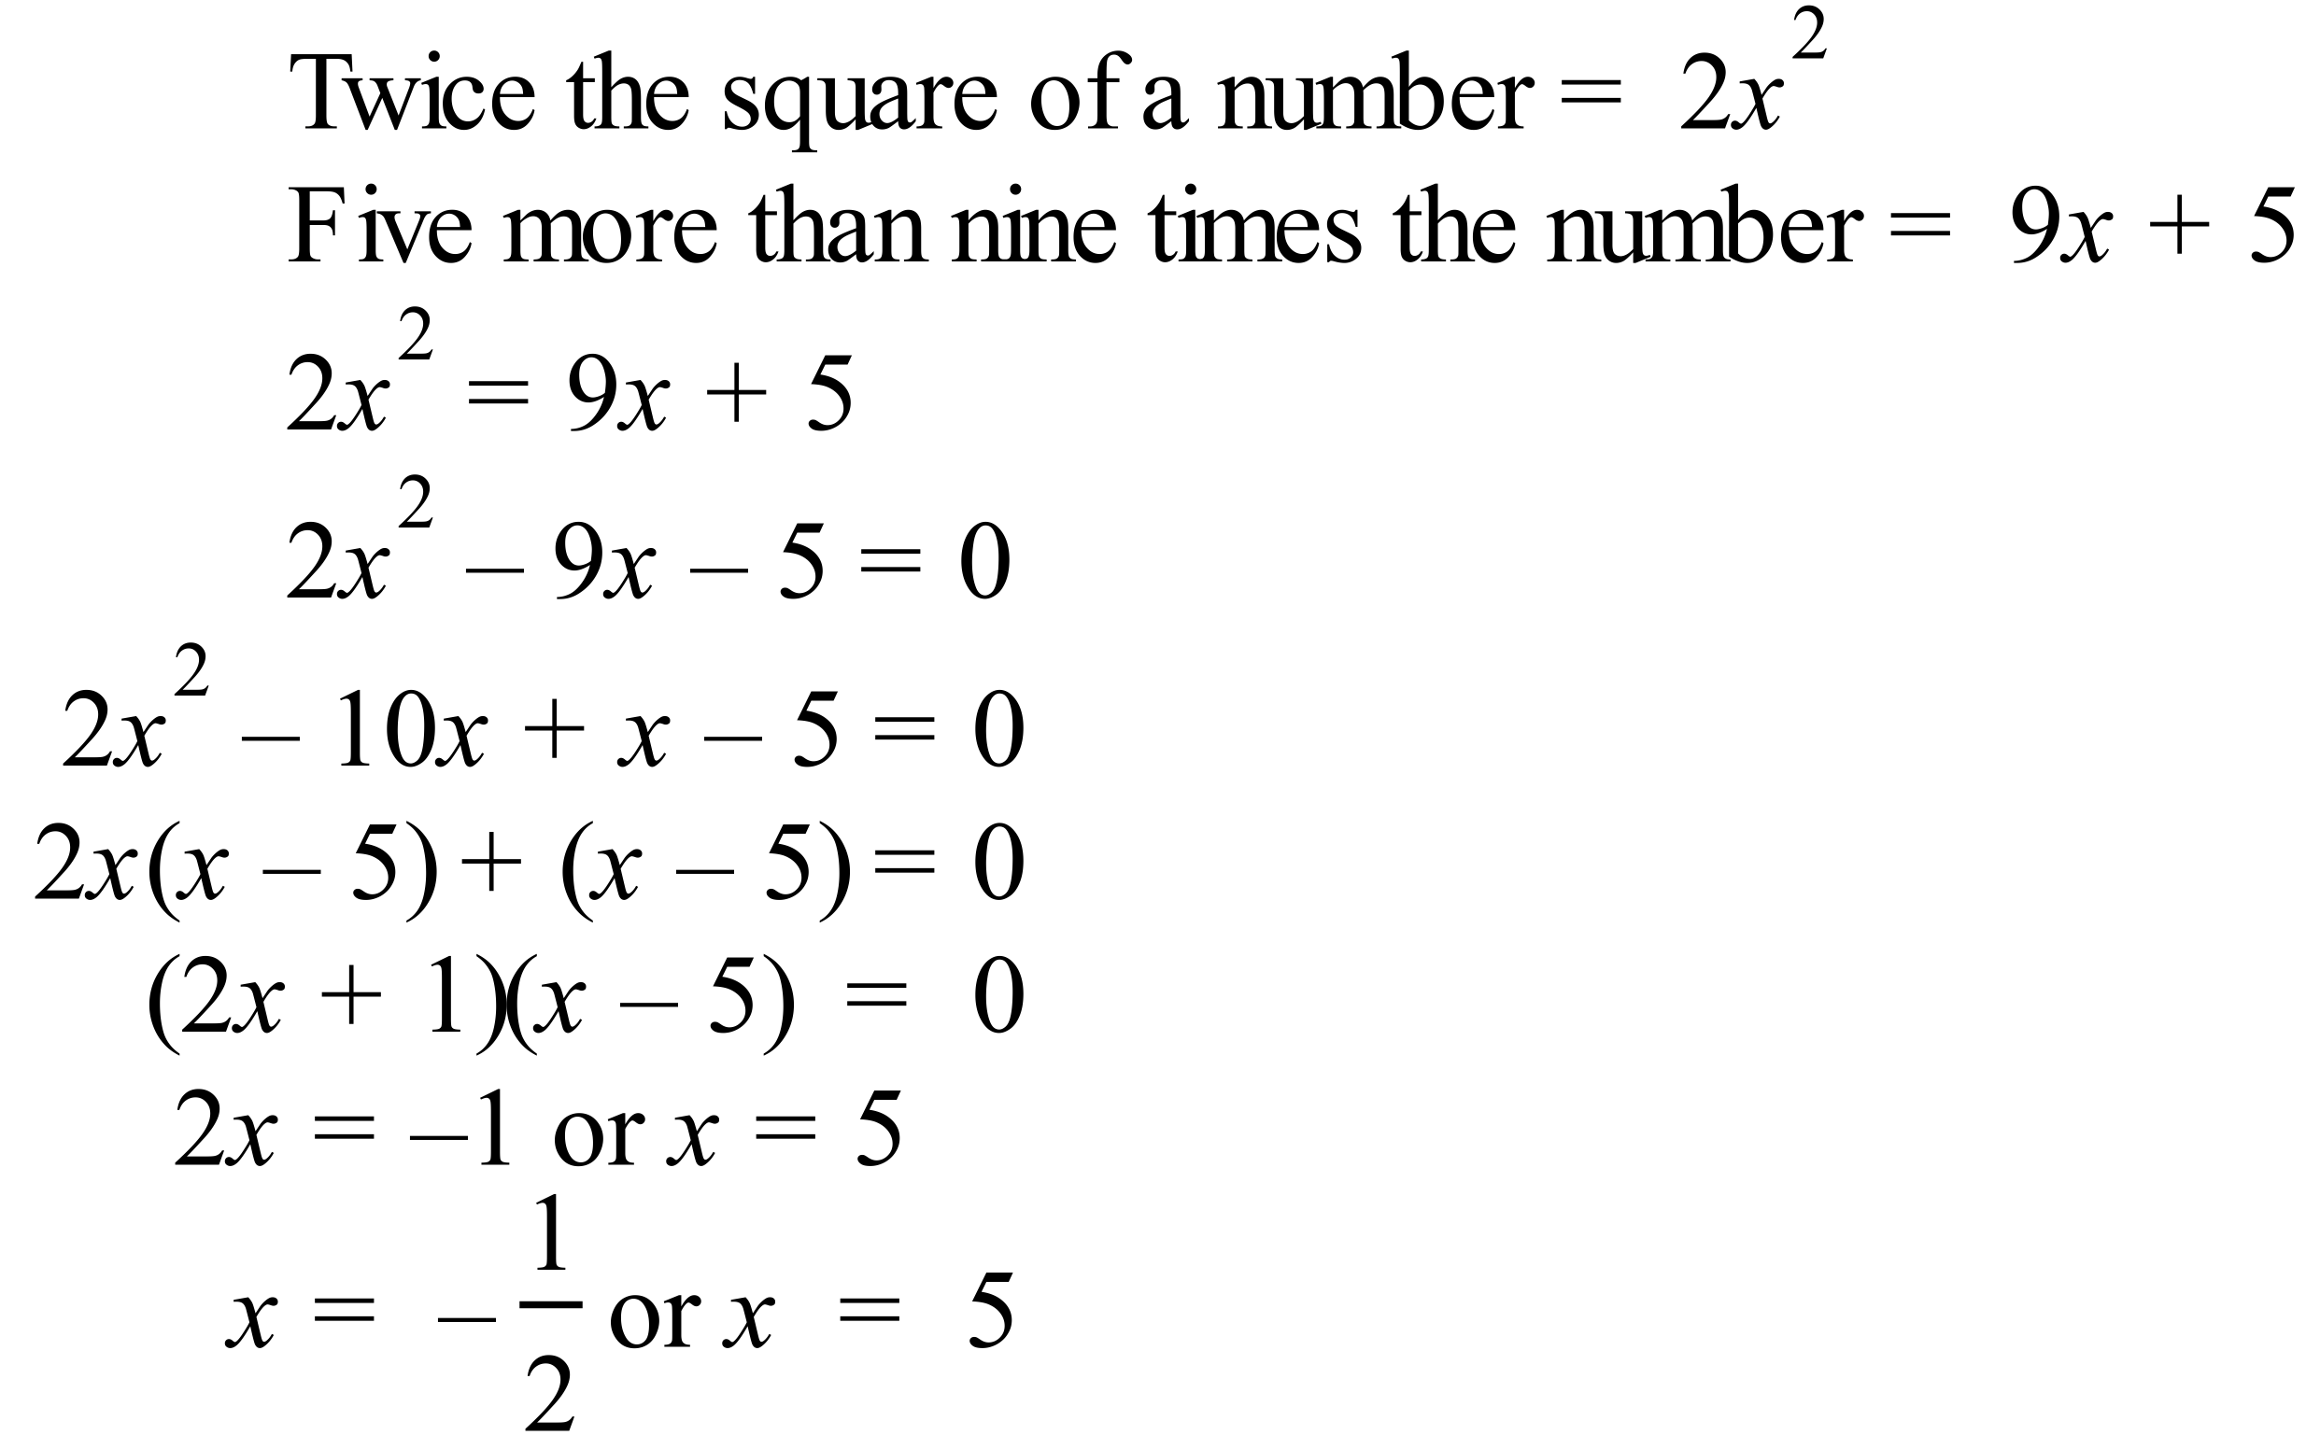  The number can be 5 or 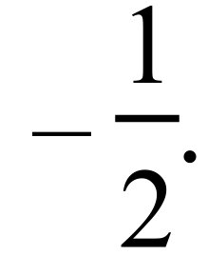 |  | 2 marks for both correct answers.  1 mark for an answer with a single error in creating the equation or in solving the equation.
 | (b) 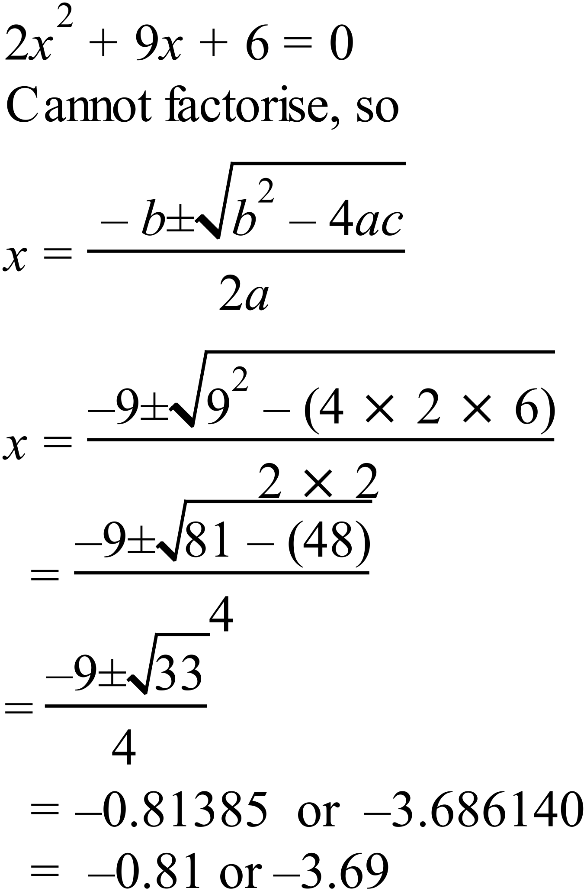 |  | 2 marks for both correct answers.  1 mark for an answer with a single error in solving the equation or evaluating the answer to 2 decimal places.
82. | 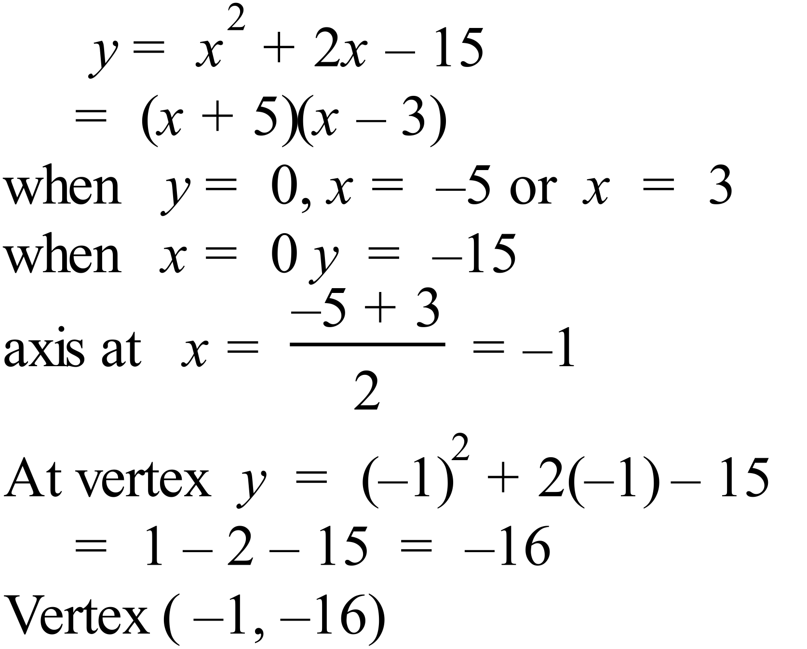  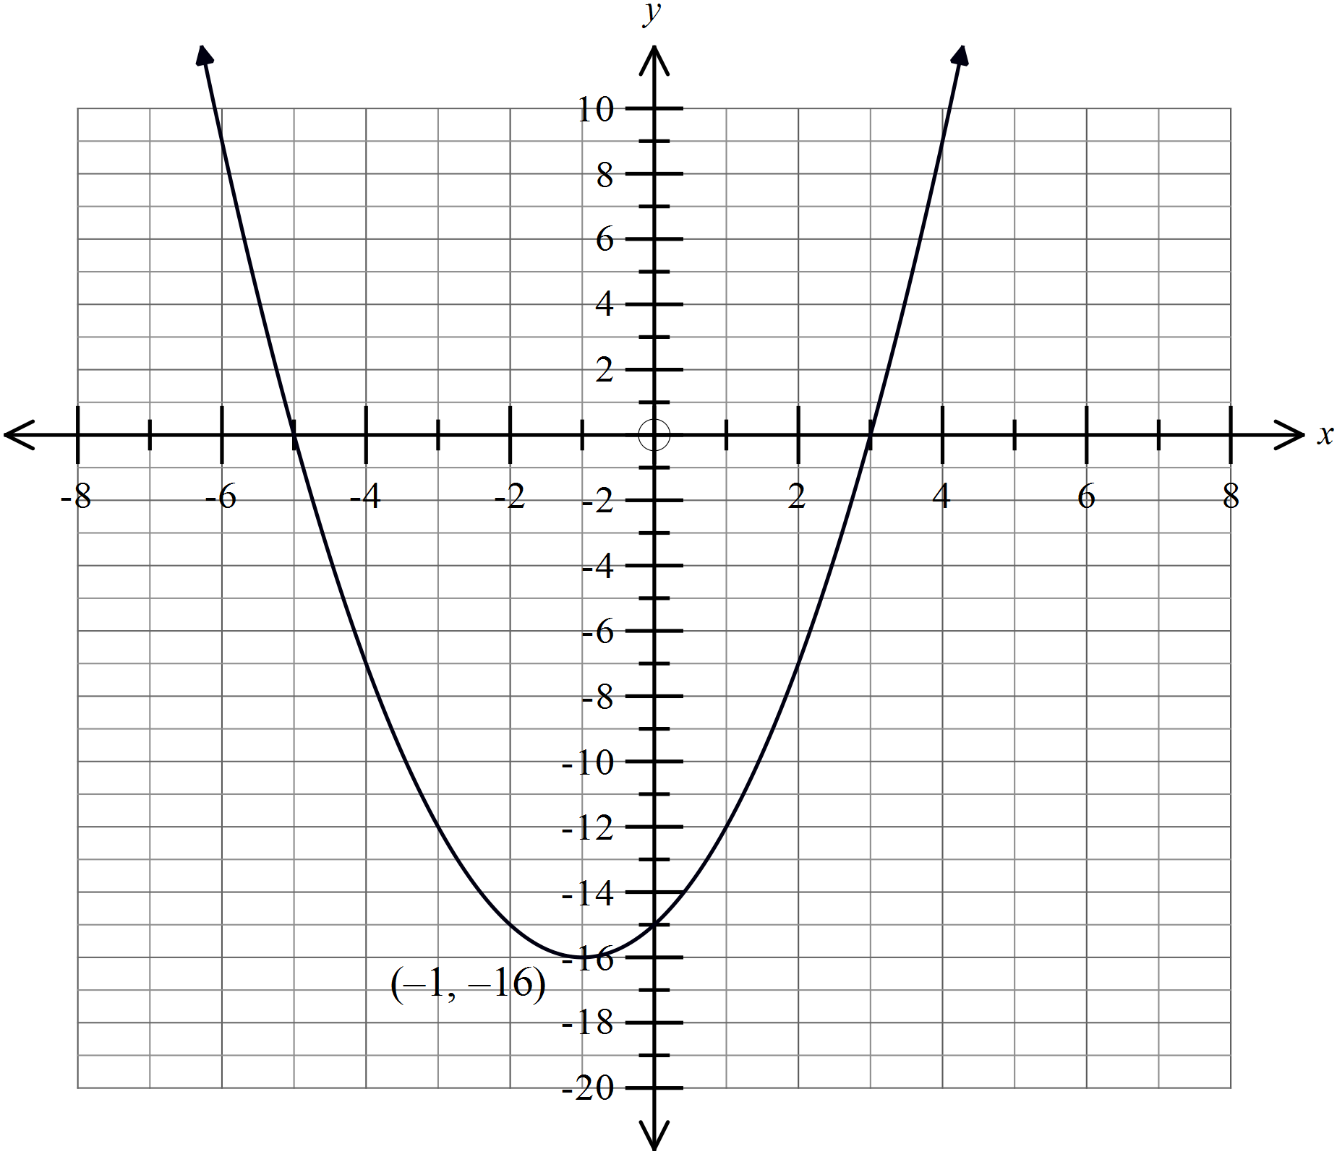 |  | 3 marks in total  1 for correct intercepts  1 for correct vertex  1 for correct shape of graph
83. | (a) |  | 1 mark for correct class centres
  Group | Class Centre  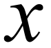 | Frequency  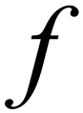
  1 – 6 | 3.5 | 7
  7 – 12 | 9.5 | 12
  13 – 18 | 15.5 | 17
  19 – 24 | 21.5 | 15
  25 – 30 | 27.5 | 9
   |  | 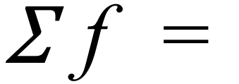60
 | (b)  Mean = 16.2 and |  | 1 mark for both found correctly, can award ½ each if you wish.
 | (c) Both schools have the same mean, but the St Brigitte’s had the scores more closely grouped around the mean (smaller spread), so there are fewer very high and very low scores. |  | 1 mark for any reasonable comparison that mentions the same mean and effect of different spread.

